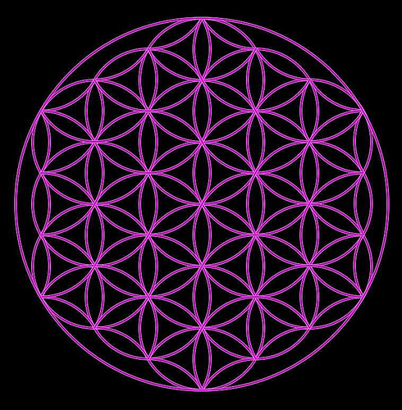

This picture will be PURPLE on a white background along with the rest of the cover page.
The
Prisoner of Claremont Street
The spine of the book will be black with a white flower of life, as above and white letters.

By: tommy mackay

The cockney philosopher

First inside page
THIS IS AN ALARM CALL
An alarm call for you, your friends, your family, all humanity. No more time left to snooze, YOU have to wake up and you have to WAKE UP NOW.

Quite possibly the WISEST investment of your time, energy and money you could make.

This book will rock your world, to the
very foundations upon which you cling.
As well as holding the keys to riches, you could never have possibly imagined

It also contains revelations you won’t believe,
about the Royals, High Government Officials, and Corporate CEOs. Plus information on the Occult and much, much more. Not only that it also has a really positive ending. ☺
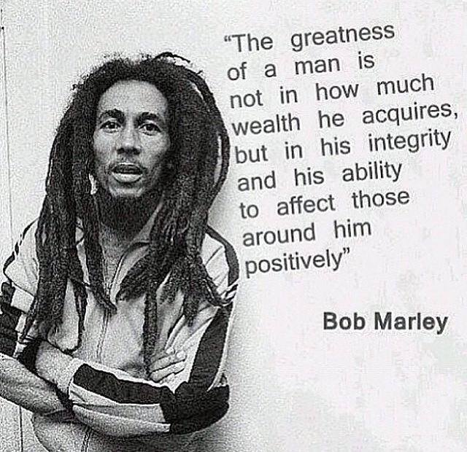
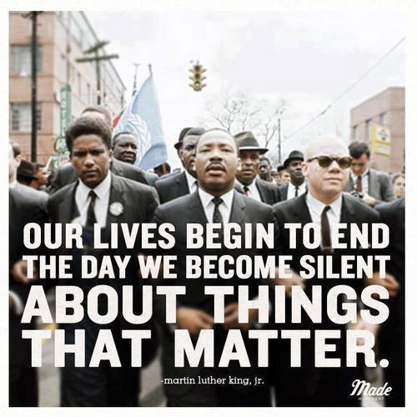
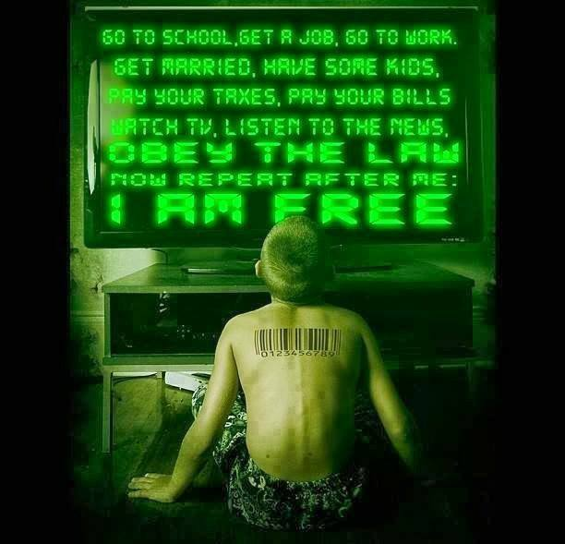
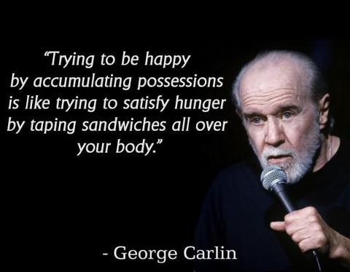

Table of Contents

Introduction
Pages 1 to ?

Foreword
Pages

Part ONE

2007 pages

2008 pages

2009 pages

2010 pages

2011 pages

2012 pages

Roman MAXIMS

2013 pages

2014 pages

Philosophical Illustrations

Dedicated To

This Book, along with another publications that
I may or may not have written,
is most humbly and earnestly dedicated with
many, many, many thanks
to all those who have come before, to those who are with us in this present time and to those who are yet to come.

We are not alone, we never have been and we never will be as long as this seemingly Herculean task is still to be properly understood and/or undertaken by sufficient numbers.

For those of who have been, for those here now and those yet to come, all your efforts can and never will be in vain.

This book is also dedicated to the work of

Mark Passio, William Cooper, Jordan Maxwell,

John Harris, Veronica: of the Chapman: Family, Michael O' Bernica and many, many others too numerous to mention.

Proof Read by Cathy Ablett-Professional Proof Reading and Editing Services U.K.

Introduction

So, with that in mind, and in order to try and save you, all of you, from much of the emotional, physical and mental pain that I have had to suffer I have consigned my thoughts to these pages. Whereby, in reading this, you are forced to re-evaluate your very existence. I hope to achieve this by helping you, the reader, to not only see, but also to instantly recognise patterns. I hope that these will be self-evident when you have finished reading this work of mine.

I have spent the last 12 years slowly digging myself out of the pit and now I am free of it forever. (It is now 16 +). After years, and years, and years of soul searching and researching, in my ultimate quest to find the TRUTH, wherever it may lay and whatever it may be. Moreover, once I finally discovered what the Truth actually was, as it could be nothing else, I also discovered that I already knew it and I had been living in harmony with it for several years. I just couldn't describe it in words, diagrams or even pictures, (Natural Law).

So in 2006/07, I started to write down my thoughts about world and local events, my philosophy of life and other philosophical thoughts, as well as some poetry (although I have spared you most of that). So, contained within this book are only some of the writings that have stood the test of time when others didn't.

So ‘why should you read this book?’ you may be asking yourself by now and that is a very good question. As you will very soon discover, your time and energy are your most valuable commodities. Which is why I do not want you to waste them, unlike many others. Part of the aim of my book is to save you as much time and energy as possible. Therefore I will be providing links to other authors as well as to YouTube presentations that I have found particularly helpful. That is one of the main reasons why you should read this book, as it will save you days or months or possibly even years in seeking this information on your own. In order to help you join the dots a lot faster and to help you to actually see the pieces of the puzzle your mind has been trying to put together for years, whether you were conscious of it or not.

The second main reason I have written this is that I'm just like you – or, rather, I was once upon a time. I went to school, got a job, worked forty plus hours a week etc. etc. etc. I have had many jobs in my life, most of them not very well paid. I would have to say that the best paid were being an Imperial Storm Trooper (British Army, Infantry, in Northern Ireland (Belfast) in 1979 and being an Undertaker (Funeral Assistant) from 1989 to 1991 (London). That is about it – the rest of the time was spent trying to make the equation of Time & Fiat Currency meet in the middle. Time & Fiat Currency – you either have too much of one and not enough of the other or vice versa. You can guess which way my balance went. Yes, that's right – too much time and no Currency or less time and still no Currency!

So who am I? Nobody in particular. Just your average Joe, as they say
in America. I was born in 1960, in the Whittington Hospital, Highgate
Hill (North London), which sounds nice. However, my parents didn’t
live in Belgravia or Chelsea, but in Stroud Green, an obscure and
less-than-lovely part of North London. I then spent my formative years in East London (Leyton and Walthamstow). So you could say that I came from very humble beginnings.

And I am still there, being a prisoner of both Disability and Poverty at the same time; living the last 28 years in Local Authority Housing in both London and Devon. I’ve spent the last 12 of those years in Claremont Street, residing in an one-bedroom concrete box, alongside lots of other identical concrete boxes. (2017 Up date, I finally got a move to the Estover area of Plymouth where I currently reside care of back in October 2015). (Because my Father we diagnosed with Dementia and my Mother had died. Not because of all the detrimental affects Plymouth Community Homes had already done to my mental health).

This book is my only way out of this prison. I hope that by helping others I will also be helping myself and what's left of my family – well, that is the theory anyway. I have been through a lot in my life. I suffered from Clinical Depression, OCD and, to an certain extent, PTSD. I also survived (just) 3 nervous breakdowns, 2 divorces, numerous suicide attempts and the untimely death of my 29-day-old granddaughter. I have beaten cancer. Well, I say beaten – I may have lost a small battle, but in the end I won the war. The

cancer hasn’t come back and it will be 19 years this year. Although this meant having so many operations and general anaesthetics that I have lost count of the actual number. Suffice to say my medical file at my local hospital is two inches thick and that is just for the last 21 years. Moreover, my strangulated hernia emergency operation left me with a ten inch scar as well as another hernia repair that became infected. Hours of fun, NOT! To be honest, in my humble opinion, it is a minor miracle that I am still here at all, let alone able to write a book. But, I am still here and I have written a book. I finally realised that one of the reasons I have had to go through all the things I have suffered was to grow and learn, which I continue to do.☺

This enables me to help others to see what I can now see. Moreover I’m aiming to do so in a language people will understand, from a person who has had similar life experiences to them, and has had to re-evaluate his whole life and belief systems in order to be finally free of the web of lies and deceit that has been deliberately and intentionally placed in his mind. Just the same as it was placed into yours. This does not mean that I have all the answers; I don't. There is still so much I want to learn, new skills and new information to digest and practise. However, I am very comfortable with the answers I have found concerning all the big questions and, at this moment in time, I’m satisfied with that.

Moreover, I'm not an academic or an accredited historian or a philosopher or one of the 1% who run this planet. I have no formal qualifications, just lots and lots of life experience and knowledge. Along with the ability to know that what you have been and are being told on a daily basis is not only a out-and-out distortion of the truth, but merely selected snippets of a distorted truth.
By reading this book and doing further research, you will have well and truly taken a few steps on the path to the real Truth, not forgetting mental and spiritual freedom aimed at reaching true enlightenment, along with all the riches that this pursuit brings..

All I can say is that I hope you enjoy this work of mine and that it causes you to ask more questions. Asking questions is where this path must begin, in the search for the answers to the ultimate question – WHY? Why are we here?

Who are we? What is the point of our existence? How can we make the best of the opportunity we have been given?

I will tell you here and now that you will know exactly when you have reached true freedom and enlightenment, as you will have run out of big questions at that point. You will know the answers to all that is truly important and that is all anyone needs to know.

Now, as to the structure of this book, I have given the matter a great deal of deliberation; as to how should I divide certain parts from others? In the end, I decided on a chronological approach. So, there are no chapters, just one part divided into years, plus the months and sometimes exact dates of when the thoughts, revelations and conclusions crossed my mind.

I have also taken the liberty of providing explanatory notes to some pieces, for various reasons. For example, some of my work relates to current world and national events. Furthermore, I will have also provided, in some cases, a potted history of facts and events that have occurred in my lifetime. Many of them have been forgotten and lost in the mists of time, although their effects are still with us to this very day, as I will endeavour to remind you.

Please note that when I use the words ‘man’ or ‘men’, I mean men, women and/or children and/or anybody in between. (You will also see that I use the term Human Being or Human a lot. As I didn't know then what I know now, that the term Hue, is a colour as in colour of man and/or woman and/or child. Therefore to a certain extent it is the correct term in the correct context, however I no prefer to use just, man, woman or child all in lower case. Then they are not being addressed as legal fictions of the system). :-).

Stand ye calm and resolute,
Like a forest close and mute,
With folded arms and looks which are
Weapons of unvanquished war.

And if then the tyrants dare,
Let them ride among you there,
Slash, and stab, and maim and hew,
What they like, that let them do.

With folded arms and steady eyes,
And little fear, and less surprise
Look upon them as they slay
Till their rage has died away

Then they will return with shame
To the place from which they came,
And the blood thus shed will speak
In hot blushes on their cheek.

Rise like Lions after slumber
In unvanquishable number,
Shake your chains to earth like dew
Which in sleep had fallen on you-
Ye are many — they are few".
P.B. Shelley 1819
This was written by Percy Bysshe Shelley after the Peterloo Massacre that took place in Manchester in 1819. It is a clarion call to all who have the ears to listen, now just as much as it was then, nearly two hundred years ago.
Which was a protest against the lack of Voting rights.

http://en.wikipedia.org/wiki/Peterloo_Massacre

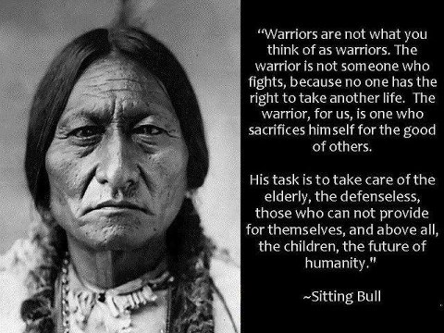

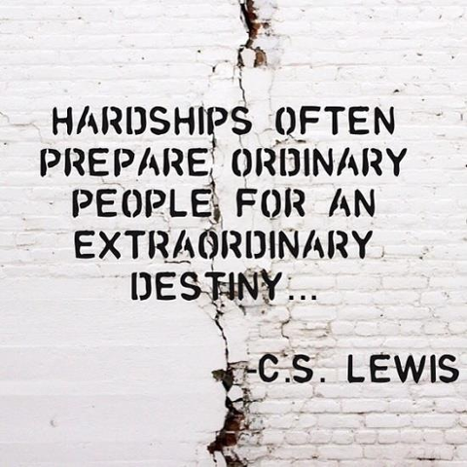

PART ONE

Mission Statement

The Meta Prayer

May I be in peace,

May my heart remain open.

May I awaken to the Light which is my true nature.

May I be healed.

May I be a source of healing for all beings.

Taught by Buddha

2007

Mother Nature

Mother Nature
is and always will be
far more beautiful than any human being.

The Double-Edged Sword

Through Knowledge there is UNDERSTANDING.
Through Understanding there is ACCEPTANCE.
Through Acceptance there is HARMONY and WISDOM.
Conversely:
Through Ignorance there is FEAR.
Through Fear there is CONTROL.
Through Control there is DIS-UNITY and ENSLAVEMENT.

Making up the numbers
I used to be better
At a lot of things, than I am now.
But now I’m a much better
man.

Our Life Essence, an attempt at a Definition

First, let’s look at the Spirit’s physical properties.
It has none.
You can’t see it, touch it, or smell it,
but you can hear it.

It talks to you all the time,
mostly as a whisper,
so quiet it is drowned out
by the noise of the day.

To hear it, you have to become very
calm and quiet in a quiet place.
Then empty your mind and listen,
since only you can hear it.

So now we know that it has no physical properties,
but we can hear it.
Therefore it exists. But where?
That is the question – Where does the spirit exist,
if it has no physical dimensions?

That is because the spirit is spiritual not physical.
and it exists in all of us.
We each have one – our very own spirit,
as well as a mind, body and, especially, a heart.

Because they are all interlinked with each other.
Take one away and we die.
That’s where Plato was wrong in
his Tri-Partite Doctrine
of Self and State.

Reason---The Mind---Head---Gold

Courage---The Heart---Chest---Silver

Desire---The Body---Stomach---Bronze

Plato failed to recognise the
necessity of the Spirit
or, as some describe it, the Soul.
Plato couldn’t comprehend that the spirit
holds all the others together.

So if we have four key elements
in the equation, there is balance.
You can’t have balance with three.
Because you cannot divide it by two,
There is always one remaining.

Therefore, with four key elements
we have balance. Which is what our
Spirits do – they balance the other three,
the Mind, Heart and Body.

Going where it is needed
to bring Balance within ourselves
and with the Universe.

How to Become Invisible

They answered their country’s call,
they took their country’s shilling.
They were young, fit and naïve.
They followed orders without question.

Doing everything on a shoestring,
while being paid a pittance.
Not enough equipment or support
and still completing every task.

Even the Americans got it right –
instead of homes fit for heroes,
we have, heroes fit for homes,
homes and hospitals that no longer exist.

Abandoned by the Queen and politicians,
left to fend for themselves in a strange world.
With no-one to fight their corner,
when they have no fight left in them.

How many have to fall by the wayside,
into drugs, drunkenness, homelessness and suicide?
These are the laurels they receive,
forgotten and shunned by their countrymen.

All because they didn't DIE.
They came back, broken and shattered,
physically, mentally or both.
The true cost is inestimable.

I wrote this poem to express my anger and frustration at how servicemen and
women were treated once their services are no longer required. The treatment is handed out by the real criminals who sent them to do their dirty work, as they are too fat, lazy and cowardly to ever do it themselves. Of course, we mustn’t forget the families of the servicemen and women, who have lost loved ones and are still, to this day, trying desperately to care for the ones they have left. They were all lied to, including me. We all believed what we were told, as so many millions and millions of us have believed it before – the NOBLE LIE(S).

Why the Pen will always be Mightier
than the Sword?

Once a Sword has been unsheathed, it can always be
re-sheathed.
However, a Pen can only be used to convey thoughts to paper. Therefore, once you have committed your thoughts to paper, they can never be unthought-of or unwritten.

FABRIC OF SOCIETY

The illusion that is the fabric of society has now been stretched so tight that it is translucent and the colours are beautiful.
They are so beautiful that they are blinding.
However, only those of us who can see it from the optimum perspective are able to see just how transparently thin it actually is.

Age Old Fable

It is one thing for you, as an individual, to be able to see and understand the TRUTH.

It is, however, quite another matter to get some people to see and understand it as well.
2008

True Power

No one individual, no one community, no one country,
no one region and no one continent is more powerful than
MOTHER NATURE.

Why are there still so many things
that divide us?
Compared to the ever-so-few
that unite us?

The Fickle Finger

I don’t tend to be very

Lucky with women,

But I don’t play cards

So what do I do?

It’s not that I don’t like them.

Most of them are very nice,

Some are even more than nice,

But very few are special.

Fate is a cruel mistress,

As she plays her game,

Laughing as she twists and turns

Our so-called destiny.

Otherwise, why do we fall in love?

Especially with the wrong people.

When there is no chance of happiness,

But we carry on regardless.

And then fate shows you

What could be possible

Without enlightening the other,

Just to rub your nose in it.

Why do you think is called,

The Fickle Finger of Fate?

It's not going to help you, is it?

The Gods are too busy laughing.

Laughing at your misfortune,

Like a living soap opera,

Just for their entertainment,

As if they haven’t got enough already.

Although worse is yet to come,

Because you can never win.

You have been programmed already,

Back in infant and junior school.

Programmed to be forever disappointed,

Because no women can assume the mantle,

The mantle of our Lady, The Blessed Virgin Mary.

The purest and most holy of all women,

The mother of Christ, our Saviour.

She is the Mother of all Mothers,

Yet no mother can emulate her.

I have prayed at her feet,

Many, many times in penance,

For sins that I had never committed.

She has damned me in this existence,

Damned me to forlornly seek that

Which is ultimately unobtainable,

Because there can be only one Mary

Unlike all the ones in Ireland.

From birth, I was indoctrinated, into the Roman Catholic faith.

With the Bible and icons, as well as the cane and the slipper.

So both Fate and Our Lady, Have damned me

To forever search for that, which can never exist.

But I also know that the world

We live in is full of infinite possibilities.

So I never give up,

Searching and searching, damned or not.

Because if I’ve learnt anything

In this life, it’s this:

The programming can

And should be broken.

For it can only have

A negative effect.

So I will break free, sooner rather than later.

Because things are never

As frightening or powerful

In the full light of day,

Where nothing is hidden any more.

Then you can finally see them for what they really are.

Writhing in the bright sunshine,

The holes in their argument

Shining through for all to see.

So now I’m free to start again

And renew my search, this time for a goal that is obtainable,

A happiness that can be realised, I am in control of my destiny,

Fate no longer plays a part, I decide what I do and don’t do.

So here I come, ready or not.

I would like to say at this point, that nobody is bound by this or any other

destiny. Once you have broken your programming, you can start again. Once your mind is truly free and free of the past and your heart is truly open. Then there are no limits to the internal happiness you can achieve, including in all personal relationships. ☺

“Political Parties
may come and go,
but Government carries on.”

Have you ever noticed that it doesn't matter which party wins
or doesn't win? Government carries on.
Even when they all go on holiday for nearly half the year.

The reason for this is a simple one – the SYSTEM of MIND CONTROL and FRAUD has to continue at any and all times, no matter which party you elect. It is of no consequence, as they all know what is going on; they just don't tell you. That would be political as well as actual suicide. This is why they keep their traps shut about that particular subject, which is ironic when you consider that all they are is a bunch of Talking Heads.

Endeavour to Persevere

I endeavour my whole life
to be the Master
only of myself.
As that is all any of us can do.

“TIME IS A PRISON

FOR THE

MIND”


To a Philosopher/Historian,
there are always two or more sides
to an argument.
To a Doctrinal Fundamentalist,
there is only one.

The easiest people to indoctrinate,
Are the ones who know NOTHING
But think they know EVERYTHING.


Power and Responsibility
Are exactly the same,
They are just
Defined Differently.



With Ultimate Power comes

Ultimate RESPONSIBILITY
(Vicarious Liability)

2009

“If you want [consent] to remain SLAVES of the BANKERS, and pay for the costs of your SLAVERY, let them continue to CREATE MONEY and CONTROL the NATION’S CREDIT”.

Sir Josiah Stamp (1880-1941)
In 1928 he was appointed a director of the Bank of England.

http://en.wikipedia.org/wiki/Josiah_Stamp,_1st_Baron_Stamp

Why is it that so-called SUPERHEROES, only exist in the medium of entertainment, yet SUPER VILLIANS exist in REALITY.
STALIN, HITLER, POL POT, G.BUSH
T.BLAIR, the ROTHSCHILDS etc.
Therefore, as individuals and as a species, we need above all to re-learn what we have been forced to forget.

Time Flies
With the ever increasing speed of Technology has come the ever increasing acceptance of what is the NORM,
as we no longer think in Centuries, but in Decades.
Moreover, with every passing decade, we lose touch with Liberties and Freedoms that our ANCESTORS won for us at such GREAT COST.

This state of affairs has also been aided and abetted by the two favourite weapons of our slave masters, deliberate prevarication of Global Conflict (Fear) along with, and never forgetting, one of their favourites:- Divide and Conquer. Or did you think that particular ploy died with Julius Caesar?



I am, along with you, a living organism dependent on our environment. Conversely, all around us, the Planet is Dying.

Lasting Impressions

Why do I always get the impression that the Happiest People on this planet are to ones with the Fewest Possessions?

I think the reason for this is a simple one, yet again. The more
possessions you have, the more you potentially have to lose,
therefore the FEAR OF LOSS is greatly increased.

Of course, this also applies to the worship of and subjugation to and prostration before the false gods of Money, Power and Control. ☺

Unlike any other species
Unlike any other species on this planet, we have to ability to do 3 remarkable things.
We can see but not observe,
We can hear but not listen,
as well as being able to speak whilst saying Nothing.

Tottenham Court Rd to Camden Town

You embark on your journey full of heady anticipation of the wonders that lay ahead.

Who will you meet on your journey; will they share the same carriage?

Will you like them, will they like you, all is fizzing in your mind.

Because no of us really know, it is all supposition.

So you take your seat, waiting for your journey to begin.

How many stations are there till my stop?

Should I get out there or travel on to the next one?

The choice is irrevocably yours and yours alone.

Then, before you realise it, the doors have shut.

Now there is no escape until the next station.

You are compelled to follow this path,

Until you reach the next station. Then choice returns.

As you sit in your capsule, plunging through the darkness,
a
although you are cocooned and illuminated,

Just outside are darkness and danger,

Ever present, waiting for the rash and surrender.

On your journey, you catch glimpses of the carriages in front,

You can see the train turning in the narrow tunnels.

Then, suddenly, the train loses power. It starts to slow.

You stop in the middle of a tunnel, not knowing where you are.

If you had to walk, which would be the nearest station?

The driver and the guard will know, won’t they?

Then a shudder and you’re off again, gaining speed.

Then, suddenly, the train roars into the next station.

People are getting off and others are getting on

And others are still in their seats, staring into nothingness,

While doing an excellent impression of a tailor’s dummy.

They have no desire to communicate with you on any level.

Then fear rises slowly in your mind,

Does this train go to Edgware or High Barnet?

It doesn’t matter, they all go to Camden Town anyway.

You start to relax and enjoy the journey again.

You slowly become transfixed by the 1930's power and signalling cables,

Flashing by just outside the glass, inches away.

They seemingly stretch into infinite time and space,

Yet you can only see a tiny section at a time.

As your mind wanders and examines

Love, Death and the meaning of life.

All the universal possibilities and configurations,

All bouncing round your mind like a pinball in the machine.

Then, whoosh, you burst into the light of another station.

This time a major intersection on the network.

Everybody around you seems to be getting off here.

As well as lots outside waiting to get in.

Their faces flash by like a dream,

Then the train stops and the doors open.

They all get on or off, struggling with their baggage,

Trying to not get stuck in the doors or lose one of their group.

Others rush in to take their places, racing for a seat.

The Alpha Males and Females stake their claims,

As calmness returns and the train plunges into darkness once more.

As you all speed off, seemingly going in the same direction?

Although at each station or intersection, things change,

None of which you can control, it’s all totally random.

But you have absolute faith in your decision.

You are going to Camden Town.

Or Chalk Farm – you can’t make your mind up.

Both have possibilities, but you must choose one.

Which one is closest to your objective?

What is your objective? Can you even remember?

Then, in the blink of an eye, you’re at Euston.

Another major intersection, more decisions.

This time involving another completely different network.

No, you say, I going to Camden Town.

Before you know it, the doors slam shut.

You’re off again, surrounded by darkness.

Your capsule is now dimly lit, you see the sparks outside.

The carriage lurches to one side abruptly.

People are thrown on top of you, the lights fail.

You can’t breathe, you’re going to die.

Bang, the electricity arcs across the tracks,

You wake up with a start. Phew, it was only a dream.

Although you completely missed Mornington Crescent.

Where the hell did that go? I missed an entire station there.

Then it hits you like an underground train, splat.

You’re going in the wrong bloody direction.

You spent all this time and energy trying to get to

Camden Town (or Chalk Farm, you still can’t bloody decide).

And it has all been totally wasted because you couldn’t see for looking.

Your final destination should have been,

TOOTING BROADWAY

Remember Citizen Smith and his famous chant,
written by John Sullivan?

“POWER TO THE PEOPLE”

Our Real Age

We all know how old our bodies are, even if no one else does. It tells us on our birth certificates.

But how old is your Soul?

Ultimate Responsibility

With Power comes Responsibility
(Because you are no longer just responsible for yourself)

Therefore with Ultimate Power comes
Ultimate Responsibility.
That is my take on power and responsibility, which I feel is supported by this quote by LORD ACTON (1834-1902)

Letter to Mary Gladstone (24 April 1881)
“I cannot accept your canon that we are to judge Pope and King unlike other men, with a favourable presumption that they did no wrong. If there is any presumption, it is the other way, against holders of power, increasing as the power increases. Historic responsibility has to make up for the want of legal responsibility. Power tends to corrupt and absolute power corrupts absolutely. Great men are almost always bad men, even when they exercise influence and not authority: still more when you super-add the tendency or the certainty of corruption by authority. There is no worse heresy than that the office sanctifies the holder of it”.
Seven years later, London was rocked by the “Jack the Ripper” Murders, carried out by person or persons unknown. Which is, as far as I am concerned and according to the research I have done, the greatest piece of evidence we have of is the quote “Absolute Power Corrupts Absolutely”.
You, of course, can draw your own conclusions. ☺

Noble Rhetoric

Why is history full of noble rhetoric that never comes to fruition? The Ten Commandments, the Sermon on the Mount, Magna Carta, the Oxford Principles, the Declaration of Arbroath, the Bill of Rights 1688, the Declaration of Independence, the American Constitution, (Original one)

Why? The reasons are always the same – Money, Power and Control; those who have it and their endless struggle to keep it. Nothing has changed in all these years and now, more than ever, those who have the most money have

the power and control and that’s is all they care about. They are not humanitarians or philanthropists. They don’t care how many will die. How many of the old, the sick and the venerable will suffer because of their greed and avarice? Not hundreds, not thousands but millions upon millions.

Moreover, this will continue for century after century, until we rise up and say NO. No more will suffer needlessly. They are human beings just like us, but because they are a different colour or worship a different god or speak a different language, we stand by and watch them die. Those who have the Money, the Power and the Control have not only turned us all into Hypocrites but into murderers. We are all Guilty of Conspiracy to Murder – thousands of children die every single day for want of food, clean drinking water and basic medicines.

So what world do you want to live in? This one or a new one? And remember, anyone who uses the phrase “New World Order” just wants to keep things exactly as they are; they just want to change the name, but nothing else will change. The rich will just get richer and the poor will still die in their millions and you will still have to watch them via the media or in real life. But, they will still Die and Die and Die and Die and Die and Die and Die and Die.

So ask yourself a question? If this is the best we can achieve as human beings, why do you still live in Fear? Fear of losing your wage or salary, fear of losing your home, fear of becoming sick and going into hospital, fear of becoming old, frail and forgotten. Fear because you can’t get your children into the best schools because you don’t live in the right catchment area. Fear of a justice system that no longer recognises the rights and tribulations of the victims, only the human rights of the criminals. I could have added some more to this piece, however I have chosen to leave it as it is. As you can no doubt tell, there was a lot of anger and frustration in my words. As it is, 5 years have gone by and nothing has seemingly changed. However, there has been a change and profound one at that and that is that, The Truth will out, as it invariably does. ☺
The Anomalies of Capitalism
Can somebody please explain to me why it’s beneficial to live in a Western Capitalist Democracy [Oligarchy], when the wrong people are continually rewarded?
Example: Why is it that the monetarily rich get what they want, when they want it, while the monetarily poor, get what they are bloody well given?
Example: Solicitors, Barristers, Doctors, Dentists, Psychiatrists, etc, etc? All of whom you have to wait to see.
Another interesting Anomaly
Why is that there is no list of the Top 100 Philosophers of All Time printed in the so-called Free Press, yet there is a list of the Top 100 monetarily Rich? (And even that is missing lots of key names)
Although I feel the answer is yet again a simple one – why would you want to become older and wiser over the years that lay ahead, when you could duped into spending every waking moment in the pursuit of meaningless Fiat Currency until the day you drop dead from the effort of it all? And you won't be any the wiser.
What the Mind cannot cope with, the Body suffers.

As, in my experience, all stress – as well as metal and emotional conflict – will inevitably lead to a physical manifestation.

The One TRUE GOD

There are only Three Religions left in this reality. There are Capitalism and Materialism, both of which require the worship of and complete devotion to the most powerful GOD ever seen:
MONEY [Fiat Currency]

As we know, as we were warned over and over again, the love of which is, and always will be the ROOT of all that is EVIL. Thereby, the more you detach yourself from the Source and Mother Nature, the more likely you are to abuse its resources, the planet and everything living upon it.

2010

There is no God; there is only the
theological indoctrination of False Gods

The Inter web is the
SWORD of Truth,
Plunged to the hilt into an
ANVIL of Lies and Corruption.

I have now come to realise and understand that there are no Gods in the sense that humanity describes them. However, there is a SOURCE, a Source of the universe and the Source of all energy and love. It requires no belief system or places of worship. It exists objectively and it will always exist, whether you acknowledge its existence or not. You can either work in harmony with it or you can work in disharmony against it.
The choice is as always yours and yours alone.

Surplus to Requirements
Question: How many of the 650 MPs at Westminster does it take to change a light bulb?
Answer : All of them. As unfortunately, none of them know where the light bulbs are kept.

Logic and Reason are the natural enemies
of IGNORANCE and MYSTICISM.

The Big Society is just another name (re-branding) for the OPPRESSION of the MANY by the very, very few.

The FUTURE always has possibilities; the past has none.

There are none so blind as those who will not see.
There are none so deaf as those who will not hear.
And there are none so DEAD as those who have stopped Feeling any emotion whatsoever.

Real Life is always done in one take and it doesn't come with a sound track. However, much you try to give it one.

Whistle Blowers

Ask you self this question – if the system of control is a benevolent one (NOT), then why are “Whistle Blowers” so vilified by their employers and the Media? Especially when they should be applauded for having the Moral Fibre and Courage to speak out. Conversely, if the system of control was what they keep saying it is, then there would be no requirement for Whistle Blowers in the first place, as everything would be working as it should – not to the detriment and harm of Humanity.

Is the exploitation of women by women any worse than the exploitation of women by men?
Or is it still just exploitation of a fellow Human Being?

What you have been told is MONEY (Fiat Currency)

Money (Currency) is something that appears to give you
Power and Control, over others,
along with unconditional Love and everlasting Youth.

But, in reality, it is nothing more than an
EMPTY CHALICE.

When the economically-disadvantaged (the Poor) de-clutter their dwellings, they don't call “Cash in the Attic” or “Car Booty”, they just throw it in the bin; it has only two real values – Administrative and Sentimental.

When you study History, you will begin to realise that when it comes to the big events that affect lots of people, nothing actually changes, apart from two things:-
the overall Body Count and the amount of Money involved. Both of which continue to escalate exponentially with every passing year.

Do Ghost Writers get paid in the afterlife?

In a supposedly Free, Democratic, Capitalist society.

There is no Freedom and there is no Democracy,
there is only Capitalism (National Socialism)


The all POWERFUL STATE
Thomas Jefferson wrote:
A People should not be afraid of its Government.
A Government should be afraid of its People.
Why? We are many and they are very, very FEW.



If the European Union is all about standardisation, then why is there no Single European LANGUAGE?
Divide and Conquer again

Only when they feel completely safe will they announce that ENGLISH will be the language of the N.W.O.

Courage

For those of you who have achieved a certain level of wisdom, you will know and understand that courage comes in many forms.

However, I feel that there is one form of Courage that outweighs all the rest and that is the Courage to still PERSEVERE.
No matter how difficult it is or how great the odds against you. Never, Never
GIVE UP.

Human Nature

Not a Treatise by David Hume, 18th Century Scottish Philosopher
Humanity does not need external or extra-terrestrial enemies;
it has itself.
We are the only species on this planet that has to create
enemies in order to control and manipulate its own species.
No other species on this planet does that. Why?
The answer is a simple one: Human Nature, your own nature as a
Human Being is being used deliberately and intentionally to control
and manipulate you, en masse. How do they accomplish this?
Firstly, through the invention of Monarchy and Organised Religion,
Secondly, through the Media, in all its many forms.
Thirdly, they create a seemingly impenetrable illusion – that you, the individual, have no power to change anything.
When, of course, in reality the exact opposite is true –
you have all the Power in the World.
How is that possible I hear you ask?
The answer again is a simple one – because you have
the Power to Change Yourself.
You have the Power to believe the illusion that has existed
since the day you were born, or not?
You have the Power to believe what you are shown and told by the world’s media, or not?
You have the Power to believe in a God or Gods, or not?
Without your power, they have nothing,
Once you finally realise that the only thing that gives other people and other things power over you – is YOU.
You can then take your Power back.
Without your willing consent and complicity, they have nothing.
Because what truly terrifies them the most is you will cut your strings and become a real life man or woman,
not just a legal entity.
A man/woman that is ultimately responsible for their own words and their own actions.
We are all equal in the eyes of the LAW,
even them.
Or you can keep on being a puppet.
The decision is yours and yours alone.
All I can tell you is that once you truly believe with all your heart and soul that you are free,
then you are
FREE
However, again – because of Human Nature – to really accomplish this, you must firstly and most importantly have learned to live with yourself, with all that that entails. Otherwise, all you would have done is create your own illusion of freedom that is still inside their illusion of freedom.

nosce te ipsum
KNOW THINE OWN SELF
The Truth will set you FREE
“However before the truth can set you free you have to first know, understand and accept the truth”.
Mark Passio, 2013
http://www.youtube.com/watch?v=C1pkJaNbzLU- Natural Law
http://www.whatonearthishappening.com

Dual Philosophy
Both Socrates and Plato knew that if enough People believed that the Noble Lie (and/or Lies) are in fact the Truth,
then they will be unable to ever tell
the Truth from the Lies again.
Which is why so many have been deceived
by so few, for so long.
Plato's Republic circa 500 B.C (Noble Lie)
Which brings me neatly to a little history lesson that may even shock you.
As we all know, money does not grow on trees,
although it can be created out of thin air.
How can this be? I hear you ask.
Well, I will tell you.
All the Central Banks all over the world have got what we used to call
"a nice little number” –
what is, in effect, a Licence to PRINT MONEY.
Mayer Amschel Bauer Rothschild (1744-1812) said:
“Give me control of a nation’s money
and I care not who makes the Laws.”
The Rothschild's could now have outright control – either in person or by Proxy – over every single Central Bank in the world.
Except 3: Cuba, North Korea and Iran. (Although it is now possible in 2015 that the B.R.I.C.K.S nations are breaking away from global system of monetary control (U.S Dollar and petro-dollar), especially Russia and China).
Libya and Syria used to be on that list, but their populations have been too distracted to notice their entry into the world of perpetual debt slavery. And, yes, that means the Bank of England and the Federal Reserve, as well.
Therefore, they print the money and then lend it to their respective governments at interest, in the form of Government Bonds.
In other words, you pay for it; you Pledge to pay back the debt, even though you never gave your consent. This system of Banking Control has been in operation since 1815, or thereabouts. And the Politicians know all about it – well, the ones that matter do.
The rest just live in blissful IGNORANCE, just like you.
This was followed in the mid to late 20th century by the coup de grace – the introduction of the Fractional Reserve system into
High Street banking
(Breton Woods Agreement 1944, Consumer Credit Act 1974 U.K)
This was the goose that was going to lay the golden egg and keep on laying them, until the People finally wake up to this global Fraud.
You can trace it all back to the Knights Templar, who were, in effect, the world’s first International Bankers. And it has been around, in one form or another, since then. Even though Usury was still a Mortal Sin at that time the Knights Templar had the backing of the Papacy, which is why they were able to call it “rent” rather than interest. Only the non-Christians collected interest and damned their souls, until the Vatican redrew the rules.
First they used Gold and IOUs. Then they used Silver and IOUs.
And now they just use IOUs (aka paper money) and Credit.
This allows banks other than Central Banks to create credit (rather than money). They will call it a loan or a mortgage (a death pledge) and use the word “money”, but there is no money – only credit and credit is not paper money. That is why, to get a loan, you unilaterally sign a credit agreement, rather than a Contract, which has to be signed by both parties to become binding. Therefore, if a bank has, say, one million pounds in the form of deposits, it can create – literally create out of thin air – ten times that amount in Credit. It can loan out 10 or 20 million in the form of Credit that you all will have agreed to pay back in full and at an exorbitant amount of interest.
I cannot do this. You cannot do this. Only accredited and/or licensed robbers and thieves (aka financial institutions) can do this. And again, the politicians know all about it and have done since the beginning. Why don't they say anything? For two reasons.
Firstly they have to keep up the illusion that pretty pieces of paper with nice pictures on them have an intrinsic value, this has to be achieved at any and all costs, literally. Secondly all political parties NEED MONEY, so they will go, cap in hand, to Rothschild and Co, in order to pay for their phoney election campaigns. Although they all need one thing more than any other – Your Consent. By voting, you are giving them that consent, no matter who you voted for or who gets elected. If you voted, you consented. That is all they need. That is one of the ways that they justify all this to themselves – you consented to it. If you didn't agree, you could have withdrawn your consent at any time. That is the reality of things and that is how they continue to look after their mates (Banks and Big Corporations) at everybody else’s expense. In other words, it means perpetual Debt Slavery for 95% of the human population. Think about it. When I started work, in the mid seventies, I got paid in cash. I didn't have a bank account and I didn't need a bank account. Now all monies – whether wages, salary, benefits – get paid directly into the BANKS. It’s then up to them whether you can access it or not. If they are closed and the machines don't work, you have no money. You only have little numbers on a screen, attached to a machine that has no pieces of paper in it. Plus, there is one more very interesting fact of which I think you should all be made aware. When you deposit any monies with a bank, they see it as you giving them a loan, yes a loan so it instantly becomes theirs and not yours. Just one more thing they always forget to mention.
You see, you didn't even notice, did you?
http://en.wikipedia.org/wiki/Fractional_reserve_banking
Money as Debt (Full Length) http://www.youtube.com/watch?v=jqvKjsIxT_8
Free man on the land web sitehttp://www.fmotl.com/Money.htm#BM1
http://www.theguardian.com/commentisfree/2014/mar/18/truth-money-iou-bank-of-england-austerity?CMP=fb_gu
Legal remedy-https://www.youtube.com/watch?v=ilW9IWrqKxY
Bank Fraud-https://www.youtube.com/watch?v=jGJWYYjFEQY&feature=youtu.be

One of the foundations of True Wisdom, is in knowing, understanding and accepting that, in reality,
you can only control two things – yourself
and how you react to internal and/or external forces.
Everything else is mere speculation.

Only those who no longer wish to be WISE,
Stop Listening.

Some things I can never remember,
Others I can never forget.

The decadence and decay of any culture or society can only be measured by the amount of lies and hypocrisy that is allowed to propagate at any one time.

To be anything but your True Self is,
by its very nature, PERVERTED.

If manners and civility cost nothing,
why are they seemingly as rare as
Rocking Horse Excrement?

Captain Sub-Text is the
Ultimate Super-Hero.
Balance
One of the main keys to a happy and contented life
is to have a Harmonious Balance between the
Mental, Emotional, Physical and Spiritual elements
of your Being.

2011

Were the talents and virtues which heaven has bestowed on men given merely to make them more obedient drudges, to be sacrificed to the follies and ambition of a few? Or were not the noble gifts so equally dispensed with a divine purpose and law, that they should as nearly as possible be equally exerted, and the blessings of Providence be equally enjoyed by all?
Samuel Adams, 1776

A body of men, holding themselves accountable to nobody, ought not to be trusted by anybody.
Rights of Man, Thomas Paine, 1771

Before we are anything
Before we are a Christian, a Muslim or a Jew, or a member of any other religion or religious practice;
Before we are Conservatives, Liberals, New Labour, Old Labour, Republican or Democrat or any other of the seemingly innumerable political ideologies available;

Before we are British, Irish, Scottish, Welsh, English
or any other nationality;
Before we are President or Prime Minister or Pope
or a supreme court Justice;

Before we are any job description that we have been given, to justify our expenditure of our only resource, our time and energy;

Before we shed a drop of blood or sweat or tears, before we are even born;
Before we are any gender, before we are a man or a women or anything and everything in between, before all of this –
WE ARE HUMAN BEINGS.
So why don’t we all start acting like human beings who, as a species, went through the so-called “Age of Enlightenment” 300 years ago?
Nov 2011
The What, the Whys and the Wherefores
Six of the most important words in the English language are: What, Who, Where, When, How and Why. Why, you may ask – which, of course, you are perfectly entitled to ask – why? Of course, you may have said: ‘what’, but that isn’t a question that’s a statement and if it is a question, then it is a rhetorical one. So why, why have I just made that statement, what, (Right Context), was the point.
The point was to highlight one of those times when ‘why’ is one of the first questions you ask yourself. 99 times out of a 100, your mind will follow a pre-programmed set of questions:
What? What was it, or what did you just say.
Who? Who was or is involved or still could be involved.
Where? Where has this incident taken place and, depending on what has happened, you and/or your loved ones might still be in danger. (Although you could argue that the what and where can be interchangeable).
When? When did this incident take place: last year, last month, last week, an hour ago?
These questions are pre-programmed at birth through DNA, in the form of survival instincts – what is the threat, who is the threat, where is the threat and when can it be expected. This method is something the World's MEDIA use against us to great affect on a daily basis (Toxic Fear Porn). Designed primarily to continually desensitise you to the Violence and Human Misery that is portrayed 24/7 on the world news media.
How and Why are always left till last, because they are the least necessary for survival. They only come into play once you have assessed the information gained in the first five questions. There is another, more poignant, reason as to why the question Why is always left till last. Once your mind has got all the answers to the first five questions, your fight/flight or freeze responses will automatically kick in, along with bucket loads of adrenalin. We have no conscious control over it, as the answers to the first five questions can take as little as a fraction of a second to calculate.
Imagine you’re walking down the road, in a town or a city, and it’s very quiet, very few people are about. You’re walking, taking in the evening air, as the darkness begins to envelop everything around you. You turn a corner and there in front of you is a bomb!!!!.
Now if I have done a good enough job, of helping you to create that scenario in your head and you have done a good job of imagining the scenario, then you would have just asked those exact questions in a fraction of a second. And what was your response? ‘Flight’ is what mine would have been. If I were a fully-trained bomb disposal expert, it may be different, but I’m not, so I wasn’t going anywhere near it.
We do this all the time, even though we are very rarely consciously aware we are doing it. How many times a day do you think you do this? Only you will know the answer to that one, as you are the one that is living your life.
The answer to that question is so dependent on what you do and where you go, where you live, how you travel from one place to another, all these factors have to be taken into consideration.
So, say you lived in London (Or any other major city) and you travelled around a lot as part of your occupation. I would have thought that you would be doing that calculation quite a lot, without even realising you’re doing it. Calculating constantly is very tiring, so we start to switch off the survival response questions as much as possible. Especially when we’re in familiar surroundings and situations. And this leads us back to WHAT? What effect is this having on everybody? Not a good one, I’ll wager. I would go as far to say that it can only be detrimental, not only on a personal level but on a social one as well. What agenda can this be serving? Certainly not a spiritual one; only the forces of darkness benefit from this constant attack on our senses.
How does it do this? Simple! We have just ascertained that WHY is always the last question to be asked. If you are constantly having to answer the first four or five, there is no time left for Why. Whereas it should be the first question you ask about anything or anybody – WHY?
Most of the time, people believe they already know the why, that is another reason it is so easily dismissed from our thought processes. The WHY is usually the most obvious question, Why do we do anything? Because we either want to or we have to.
Why do you go to work? Away from your family and loved ones, either working, or preparing for it, or travelling to and from it. Because you need currency, currency buys you the things you need to survive: food, water, heat and light, plus other little luxuries like cable TV and the internet. The list is endless (well, very nearly). So, as you can see, the Why starts to become superfluous, most of the time, so we forget to ask. Especially if you are confident that you already know all the answers as to why things are the way they are. Teenage boys are especially prone to this deluded state of mind.
Although they always seem to skip the reasoning behind any such knowledge. This, of course, breeds both compliance and complacency, which is just what was ordered by the forces of darkness – lots of all-knowing and yet totally ignorant people, all running around spouting the same old rhetoric at each other, with not an original thought between them.
That is why; WHY is the most important question to ask and to ask first not last. Why does the perceived reality that surrounds us exist in the first place? The Why will then inexorably lead you back to all the other questions: what, who, where, when and then, of course, how.
So start asking yourself right now: WHY?
You will be amazed at where that one little question will lead you. Whether or not you like the answers is quite another matter. ☺
      
Understanding
It is my Belief and Understanding that, as a species, we can pretty much agree on what doesn't work.
Even if we can't agree on what will.



If this is a democracy, then why do we need
Lobbyists?

If a free press is owned by a small group of people,
How can it really be free?

What are you actually Free to do?

Work 40+ hours a week
Exchanging your time and labour for forms of currency.
You’re free to retire at 65 or thereabouts,
To find that your pension is now
Worth next to nothing.

So you have to go back to a job
You hated in the first place,
Because there is nothing else you can do.
And you get to be treated worse than cattle,
In the daily commute.

You are free to die alone and forgotten,
Then your body putrefies, maggot food.
Or to slowly waste away in a
Home where nobody asks
Your opinion, because no-one cares.

You are free to watch Mankind
Destroy itself, along with everything else on this planet.
So if we are all free to do these things,
Whether we want to or not.
Then what is Freedom?

Why is it that, good news travels fast,
But bad news travels at the speed of light?

Principles (First Things First)
Did you realise that you can still find people with no Money, no Power and no Control on this planet, yet they still have Principles, along with Ethics and Morals. Even though they are constantly coerced, persuaded and tempted to abandon them 24/7.
Conversely, there are also lots of people who have lots of Money and then falsely believe that they have Power and Control,
and they have no Principles, no Ethics and no Morals
WHATSOEVER.
Perception
Most people go about under the illusion that what they perceive to be the Truth is the Truth and that what they perceive to be Reality is Reality,
When nothing could be further from the Truth.
Your Slave Masters know this only too well.
This is why they are pursuing the painstakingly difficult task of changing what you and everybody else perceives as reality. It is happening so slowly that it appears that nothing has changed. The reality of it is the exact opposite – everything has changed. It’s just that there is no longer anyone around who can point it out to you.
Therefore, the American and French Revolutionaries of 1776, and 1789, would not recognise 2011, as Freedom. They would see it for what is really is, just another form of Oppression. They would see that all their efforts were in vain, as all that has changed is that we now we have Governments instead of Aristocracies.

And our rulers still, to this day, believe as you do – that they have power over us, while we have no power over them. Where again, in reality, the Truth is the exact opposite – we have all the power and they have none.
All we have to do is to Re-Claim it.
Or do you still believe that another Human Being has more rights than you do, or that you have less rights than them?
Yet we are all born equal, with inherent and inalienable Rights to Life, Liberty and the Pursuit of HAPPINESS. Provided it is within the boundaries of both Natural and Common Law, of course:-
The Common Law: The LAW of the Land: is
1:- Harm None.
2:- Do not take that which does not belong to you.
3:- Do not damage that which does not belong to you.
4:- Do not make mischief in your contracts.
How simple is that?
And that it is why it is everyone’s Duty to know the LAW (which is a Roman Maxim).
And now you do know. ☺
2012
“Today, America would be outraged if UN troops entered Los Angeles to restore order. Tomorrow, they will be grateful! This is especially true if they were told that there was an outside threat from beyond, whether real or promulgated, that threatened our very existence. It is then that all people of the world will plead to deliver them from this evil. The one thing every man fears is the unknown. When presented with this scenario, individual rights will be willingly relinquished for the guarantee of their well-being granted to them by the world government.”
Henry Kissinger - Bilderberg Conference, 1991, Evians, France

This quote by Henry Kissinger is a perfect example of the Hegelian Dialectic in action
Thesis - Anti-Thesis – Synthesis
Or as David Icke Explains it
PROBLEM – REACTION – SOLOUTION.

The Human Borg
You will be assimilated
To a certain extent you already have been assimilated,
through the tools of Culture and Music,
aided and abetted by the Media in all its forms.
Don't believe me – just go to any major city where there are foreign tourists and students and you will be unable to distinguish them from the indigenous population.
Why? Because they all dress the same, (Urban Camouflage),they all have mobile phones, cameras, headphones, all the paraphernalia that goes with life in the post-modern 21st century.
In every major city in the world, you will be assimilated by the same burger, pizza and coffee shops that you have in your local high street. They look just the same as every other high street, that is if you even have a high street left ...
The next phase of the assimilation of Humanity is, of course, the shopping mall or, as I call them, the Cathedrals of Capitalism.
Malls as are the only places that are full on Sundays.
Your children now worship the False God of Materialism in this sanitised and observable safety. Plus you don't get wet when it rains if you’re in a shopping mall.
All the same shops, all over the country, all selling the exact same products. You are shepherded through glass atriums, with lift music and escalators to whisk you off to your heart’s desire.
You can buy, for example, the latest strip of your favourite team, whether it be Football, Rugby, American Football, Formula 1
– the list is nearly endless.
These brands are now completely GLOBAL. There are people in India, Thailand, China, all supporting football teams like Manchester and Liverpool. They will never go to those cities and, even if they did, they could never afford a ticket, even if they could get their hands on one. Just like many of the supporters in the UK, they will never go and see their team play, since they can't afford the ticket prices for this supposedly working class game.
The operative word being ‘game’. It’s all a game, all of it, and it’s a game we always lose. Why? Because we don't know the rules.
Imagine playing Monopoly where there were no written rules. There are only verbal ones made up by the banker, who holds all the money and all the property. All while being able the change or adapt the rules to suit themselves.
That is the game you have been playing your whole lives, the game of steady and constant assimilation of cultures – music, fashion, TV, gadgets, everything – into the world where the bankers make the rules and you can't even remember what they were at the start .
However, there is a way that you can win this game, that is why the bankers don't want you to know it. How do you win this game and never have to play it again?
Easy! You free your mind. Once your mind is free, the rest of you will follow. Then you will no longer be a human cyborg, playing a game you can never win, because all the odds are stacked against you. You will be FREE and you can show them that you are free by not consenting to even picking up the dice. ☺
Instant Democracy
With the technology we now have available, with the speed of the internet, we could all vote, all of us, on every single major issue that affects us and our fellow human beings. This would be easy and simple as signing an e-petition. It is the democracy we will never get, because it really would be democratic and that can never be allowed.
We could give them the benefit of the doubt and presume that this is just an oversight, something nobody ever considered.
Or was it deliberate? You decide.
With internet referenda, we would no longer need MPs and their fraudulent expenses, no Ministers, just enough civil servants to implement the agreed policy and action.
As opposed to the system we have now, whereby you get to cast your vote for the same set of talking heads that all spout the same rhetoric 24/7, whilst blaming the other side for things that they would have done as well. So every four or five years, you get your chance to elect the next bunch of liars, who promise you the moon (well, almost) and then just carry out the policies of the Bankers, whether you like it or not.
Which of you voted for the bedroom tax?
Which of you voted for ATOS?
Which of you voted for the illegal invasions of Iraq and Afghanistan?
None of you did. Well, I hope you didn't.
If we had instant democracy in 2001, the invasions would have never taken place, ATOS would be non-existent and we certainly wouldn't have bailed the bankers out in 2008. So is Western Capitalist Democracy still working for you? Or are you starting to see it for what it really is – a collectivist, totalitarian all-powerful STATE in which you get one or the other: National Socialism or Communist Socialism. There is no other choice, just the illusion of choice and the illusion of democracy.
Or, to put it another way, one of the oldest tricks in the book, as used by every magician through the ages.
They will tell you quite openly and in front of witnesses:
“pick a card, any card you like”.
And yet they already know which card you will choose, as that is the trick – to get you to pick the card that they want you to.
The illusion of democracy works exactly the same way, because the cards are stacked against the punters, every single time. As all the options you have been given are already bought and paid for by the Bankers and Multinational Corporations.

Only when your mind is ready to see the path,
will it appear.
Expansion on Socrates
I’m reasonably sure that there are people kind enough to say
That I possess a vast amount of knowledge and life experience,
In a varying degree of subjects and situations.
However, I am also totally aware that all my
Knowledge and life experience are as nothing compared
To everything I can and will never know.
On the Path to Enlightenment
Those who arrive at their destination
Teach those who are still on the path,
While those still on the path
Are sources of wisdom for the teachers.

The Ultimate Perceivable Truth
There is the truth and then there is The Truth. It is for you to decide which one you will believe. However, be careful, as it actually depends on what you as an individual can perceive. Which means you will either see and understand this statement or you won't. It depends on what you perceive to be the truth.
The System, definition of: - "The Matrix is a system, Neo. That system is our enemy. And when you’re inside and look around, what do you see? Businessmen, Teachers, Lawyers, Carpenters, the very minds of the people we are trying to save. But until we do, these people are still a part of that system and that makes them our enemy. You have to understand: most of these people are not ready to be unplugged and many of them are so inured, so hopelessly

dependent on the system, that they will fight to protect it". – Morpheus, the Matrix, 1999
However, there is only one real Truth. When you are finally able to perceive it and start to align your thoughts, emotions and actions with it, then you have finally found the ultimate Truth. Then and only then will your belief, your faith in the ultimate Truth be unshakeable.
That is why the Matrix is so powerful in the first place – it is a prison for your mind. Once your mind is imprisoned, your body automatically follows because it has to. That is where your ultimate freedom lies: inside your own mind.
Once you believe you are free, you are free. It is as simple as that. How you will you know you are free? You will know, just the same as when you’re in love, you just know. Once you are free, the only person who can enslave you again is you.
You either choose to be free or you chose to be a slave, the choice is yours. It always has been, that is why the system is designed to make sure you never make that choice or even consider the argument in the first place. Your head is filled with trivialities. Why do you think Trivial Pursuits is called Trivial Pursuits? Because that is what it is, a trivial pursuit of useless information. Meanwhile, you have absolutely no idea who is actually running the show, but, you do know that Lima is the capital of Peru.
Which I am sure will come as great consolation when you allow the last of your rights to be taken away, on yet another pretext of freedom and/or national security?
“Never forget that everything Hitler did in Germany was legal”. Dr Martin Luther King.

The War of and for our Souls

Whether you realize it or not, most probably not, you are engaged in the greatest battle this species has ever faced in its entire history.
Yes, that is right, you can believe your eyes. That is what I just said, the greatest battle our species has ever faced. So you may ask that, if we are in a battle, who are the protagonists, where are the casualties, who are the heroes we are supposed to adore?
These are very good questions to ask, which leads us to another question. Did you answer yes in your head when reading this line , or did you think of anything as you read the one before or the one before that? Or did it take you until you had read it all, or even after, to see its relevance or point? Of course, only you the reader knows the true answer to this question. Whether you are truthful to others about it is another matter. But, you know the truth of it, that can and will never change.
However, you can. Change, that is. It’s just a case of knowing whose side you are on, which brings us very neatly, I thought – to the Protagonists, the diametrically-opposed forces in this monumental conflict.
That is one of the easier answers; there are basically only two
the Forces of LIGHT and the Forces of DARKNESS.
So which side are you on or with? This is yet another simple answer.
Unless you are consciously aware that you are with the Forces of Light,
then you are with and for the Forces of Darkness.
Hold on, I hear you say. How can I be with and for the Forces of Darkness, when I didn’t even realize until just now that there was a war in the first place? Firstly, don’t be too hard on yourself; I was, for much of my life, just as unwittingly compliant as you. I had absolutely no idea this battle was being fought all around me, from the day I was born, in April 1960.
For 42 years, I struggled with the internal dilemma, never finding any answer to my questions. Even then, it took several life changing events for me to start to look in the right place for the answers – bladder cancer at 36 and 3 nervous breakdowns, 2 of which coincided with divorces. It left me with no bladder, PTSD, OCD and Clinical Depression.
So believe me, I’m not judging or condemning you or anybody for not being able to see what I can now see and know what I now know. I was just like you for 42 years and then I started to wake up. You can do the same, I’m nothing special and if I can do it, anybody can. How do I know this? Because, all the answers to all the questions you have ever had are already inside you. You just have to learn how to access them.
At this point, I must reiterate that no-one can force you to do this. It is entirely your decision, your choice. Why? Because only you can do it, I can’t do it for you. This isn’t about quick fixes, it takes time and effort. Sorry to disappoint those of you who were hoping it would be fast. You can stop reading now if you want, put this down and forget all about it. Then you will just go on being a minion for the Forces of Darkness, which is exactly what they want you to be. So well done, you will have carried out your programming to the letter.
So, to all of you who are reading this book, and have got this far, in a way you have already taken a tiny step on to the path. How do I know that some people have stopped reading and thrown this book aside? Because that is what they are programmed to do.
To begin with, this is fundamentally about breaking your programming, to become the person you really are, whoever that maybe.
So ask yourself why you do the things you do. Why do you have a job, a bank account, debt and the overriding concern about fiat currency (sorry, that’s “money” to you). What happened to those dreams you had when you were a child? The ones where not only you and your family were happy, but everybody was happy, and no one starved to death or was driven into prostitution just to earn enough money to stay alive. Where every other child on this planet had everything you had or more.
Obviously, there are going to be some of you who wouldn’t wish your childhood on anybody, but you all know what I’m saying.
Life was so simple then.
So what happened? Why is it that we are still faced with the same problems? Why are children still dying of hunger, diseases and neglect all over this planet? The answer is that that is what the Forces of Darkness want to happen, so it does.
So who exactly are the Forces of Darkness? That, I’m afraid, that is much too complicated a subject to go into here. I hope you will do your own research and discover who they are. Although one thing that is not in doubt is that the Forces of Darkness far outnumber the Forces of Light. Why? Because they have billions of mindless slaves to do their work for them. These minions are, of course, totally unaware of the consequences of their thoughts, words and actions. That is why they continue to support the insupportable and defend the indefensible.
Throughout the supposedly free capitalist democracies, there are Central Banks that distribute the fiat currency. Is it just a coincidence that neither Iraq nor Afghanistan had Central Banks in 2000? Gaddafi’s Libya never had one either.
Hold on! I can see a pattern forming here. So, who is next?
Well, possibly Somalia, Sudan or Syria. But the two to really worry about are Iran and North Korea. You see, the forces of darkness don’t mind which
dictator or despot is nominally in charge of whichever country,
as long as they have a Central Bank, that they can control.
Once they are allowed to control the fiat currency, the Forces of Darkness are perfectly happy. When they control the money, they control everything and everybody. Just like they do here in the UK, in the US and EU.
You and I and everybody else has been lied to and controlled since the day we were born. If you don’t believe me, look at your birth certificate. You will find that when your parents registered your birth, you were given into the custody of the State.
You will find it at the bottom that you were given into custody by your parents, one of whom was an informant, IE they informed the authorities of your existence and then gave you away to the custody of the State. Your children, if they have a birth certificate, don’t belong to you. You just look after them and, if you don’t do a very good job, the State comes along and takes back their property.
Why is it, do you think, that all those Travellers in the soon-to-be-demolished site just outside Basildon still have all their children with them? You would have thought that most of them would be in care, but no, they are all still there. Why? Well, I don’t know this for a fact, but I can come to a well-educated and informed conclusion. They never registered the birth of their children, who therefore are not the property of the State, so Social Services can’t lay a finger on them, since they have no power of ownership over them.
Don’t think for a moment that you are free when you reach 16, or 18. Then you have a National Insurance number. Mine, is WK78 something, something. You all signed up to this the same as I did. Of course, we were never told exactly what we were signing up for, mostly because the people carrying out the procedure didn’t know either. We were just given the form at school and told to sign it. In that very second, you became a vessel, a corporation, your strawman was made real. You also became an employee of the State or, to put it another way, a fully paid-up club member in your own right. You don’t need an adult to sign you in any more. This gives you access to all the clubs benefits – free healthcare, free education for your children, an old-age pension and somewhere to live when you get old and frail. (Benefits and Privileges)
For this, of course, you have to pay the membership fees, otherwise known as taxes and duties. That is why you have to work and you put yourself into debt to obtain the money to pay the membership fees. Otherwise, they limit your access to the most beneficial parts of membership. This club has many forms of membership card, the National Insurance card being the lowest. However, we all have one, even Sir Alex Ferguson and Sir Alan Sugar have one. Although I would be prepared to wager that none of the Rothschild family or the Windsor family have one.
So what is the strawman, the vessel, the corporation that is you? Check out your driving license or tax return or council tax statements – your name, exactly the same but all in upper case. That is the corporation, named after you, which they created and control.
This takes me back quite nicely to my original point: who are you and what side are you on? The YOU that they created only exists on paper. It is an illusion, with which they can control and manipulate you, the real man/woman. The real YOU is the one who has been programmed to accept all the lies and bullshit they continually throw at you 24/7.

Everything you see, hear and read in the mainstream media is all part of the illusion – the illusion that life is shit, get used to it, because there is nothing you can do about it. In reality, the exact opposite is true, as people or things only have power over you if you give it to them. You, the man/woman, are the most powerful force on this planet and they are well aware of this point. That is why the Forces of Darkness, have woven such an intricate web of deceit and lies, in order to baffle and confuse you. So even if you do start asking questions, you are very quickly misdirected and sent down blind alleys until you give up. They need your power, your energy, your industry, otherwise it all collapses.
Only through your continued co-operation can the system maintain itself. Therefore, it only has power over you if you give it power. This is about taking that power back, becoming your true selves. The basic elements of consciousness never change. We all inherently know the difference between right and wrong. You know when you are doing something wrong, it is a conscious decision by you to do it or not to do it.
The ability we have, to still do wrong even though we know it to be wrong, has been with us since we set foot on the planet. For this reason we humans gave ourselves a set of rules to live by, that I call NATURAL LAW and/or COMMON LAW. Please look these up. I’m sure there won’t be anything that you won’t disagree with, as what is good for you and yours is good for everybody else as well, including the planet.
Remember the words of the CEO of the Corporation that is the UNITED STATES, George Bush, in his speech at ground zero, after 9/II. “If you’re not with us, then you’re against us”. Or has he said you’re with the terrorists, while forgetting to mention that if you’re with him and his ilk, then you are already with the terrorists. It is as simple as that. You are either with and for and fully support, whether knowingly or not, the Forces of Darkness.
Or you aren’t and don’t.
This battle has raged ever since mankind first started to build communities, however, it has intensified since the mid-17th Century and continues today; to this very moment, in point of fact. Why did it intensify in the mid-17th Century? Well, there are a number of reasons. One of the most significant has to be industrialization. The Industrial Revolution changed this planet beyond all recognition.
Machines are now everywhere. We can’t live without them and thereby they control us far more than we can ever control them.
This brings us neatly back to the now, this moment in time. The battle of and for our souls is going on right now, it’s going on all around you as you read this. Someone has been wrongly imprisoned, someone is being tortured, a child has died for the want of medicine and this one you can bet your house on – all over this planet, there are politicians making false and misleading statements. Just because you can’t physically see or hear it, doesn’t mean it isn’t happening.
So what has to happen before you start to wake up to the reality you inhabit and you start asking some questions, not only of yourself but, more importantly, of them.
MAKE THEM ACCOUNTABLE.
Even if that leads to the final accountability for all of us. At least when it happens, and it will happen, you will know whose side you are on and why you’re on it. Everything else is between you and your conscience.
And whatever you do, please don’t say you didn’t know. That has to be the lamest excuse since the guards at concentration camps said they were only following orders.
“ They who control the food supply controls the people; they who control the energy can control whole continents; they who controls money can control the world.”
-Henry Kissinger
This quote has never been attributed to Kissinger, however, I am sure that he and his cronies wholeheartedly agree with its sentiments.
The Long and Winding Path to Enlightenment
The long and winding path to enlightenment may be difficult and treacherous at times. It winds its merry way up hill and down dale to its transcendental resting place. Therefore, once you place your foot upon it and take your first tentative steps, there is no other path to follow. Though you may stop along the way, for whatever reason, you are inevitably drawn back to the path, but only when you are ready to recommence your journey to true enlightenment.
Well, we all made it into 2013, although I must admit I was caught in the twin headlights of the London Olympics and the end of the world on the 21st Dec 2012 for quite a while. Along with supposed comets and other objects on possible collision course with Earth. We live and LEARN. ☺
ROMAN MAXIMS
What are Roman Maxims? Well, they are quintessentially pearls of wisdom passed down through time. They are considered by all to be indisputable and indefatigable , TRUTHS in LAW.
This is why they are still as valid today as they were when they were written down in Roman times. Although the so-called “powers at be” don't like to be reminded of them. An officer of the High Court in the City of Westminster WC2 told me (and I have the letter) not to send them any more Roman Maxims. So it would appear that some people don't like to be reminded of the TRUTH.
"Qui tacet, conaentire vidctur".
"He who is silent appears to consent".
"No man ought to be burdened in consequence of another's act".

"Anyone may renounce a law introduced for his own benefit".

"He who receives the benefit should also bear the disadvantage".

"One who avails himself of the benefits conferred by statute cannot deny its validity", (Government Criminals).

"Usury is odious in law". (Usury is charging interest).
[Exodus 22:25, Leviticus 25:36-37, Nehemiah 5:7,10, Proverbs 28:8, Ezekiel 18:8,13,17; 22:12]

"A contract founded on a base and unlawful consideration, or against good morals, is null".

"One who wills a thing to be or to be done cannot complain of that thing as an injury".

"No action arises out of an immoral consideration".
"No action arises on an immoral contract".

"He who approves cannot reject".

"He who does not forbid a crime while he may, sanctions it".

"Gross negligence is held equivalent to intentional wrong".

"Punishment is due if the words of an oath be false".

"An unequivocal statement prevails over an implication".

"He who does not forbid when he might forbid, commands".

"The government cannot confer a favour which occasions
injury and loss to others".

"The government is to be subject to the law,
for the law makes government".
"The law is not to be violated by those in government".
"Let justice be done, though the heavens should fall".
"One who commands lawfully must be obeyed".

"If you judge, understand".

"To a judge who exceeds his office or jurisdiction,
no obedience is due".

"A twisting of language is unworthy of a judge".
"A good judge decides according to justice and right,
and prefers equity to strict law".

"He who decides anything a party being unheard,
though he should decide right, does wrong".

"Hasty justice is the step-mother of misfortune".

"No-one should be judge in his own cause".

"Justice is neither to be denied nor delayed".

"That which was originally void does not
by lapse of time become valid".

"The law shall not, through the medium of its executive capacity, work a wrong".

"An argument drawn from what is inconvenient is good in law, because the law will not permit any inconvenience".

"The law which governs corporations is the same as that which governs persons2, (Legal Entity-Fictional Person, the name on the Birth Certificate).

"Ignorance of fact may excuse, but not ignorance of law".
"Ignorance of law does not excuse, as it is the duty of everyone to know the law".

"The law punishes falsehood".

"When reason, which is the soul of a law, ceases to exist, the law
itself should lose its operative effect."

"The law sustains the watchful".

"To investigate is the way to know what things are truly lawful".
[2 Timothy 2:15]

"Those who do not preserve the law of the land, they justly incur the awesome and indelible brand of infamy".

"The principal part of everything is the beginning".

"A neglected duty often works as much against the interests as a duty wrongfully performed".

"Failure to enforce the law does not change it".

"The greatest enemies to peace are force and wrong".

"Things taken or captured by pirates and robbers do not change their ownership".
"The multitude of those who err is no excuse for error". [Exodus 23:2]

"No man ought to derive any benefit of his own wrong".

"No-one ought to gain by another's loss".

"No-one ought to enrich himself at the expense of others".

"No-one can improve his condition by a crime".

If you know not the names of things, the knowledge of things themselves perishes; and if you lose the names, the distinction of the things is certainly lost.

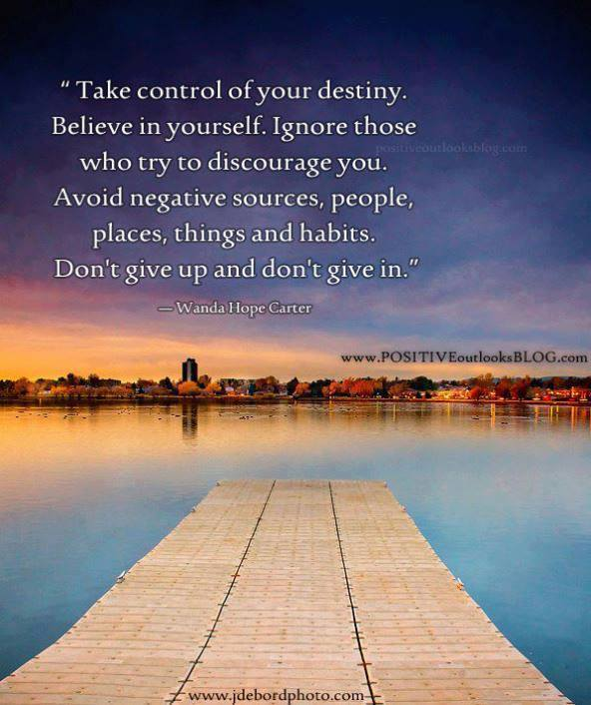
These are just a few of the Roman Maxims
and they are easy to find on the internet.

2013
"We shall have World Government. Whether or not we like it. The only Question is whether World Government will be achieved by conquest or consent."
James Paul Warburg, (Banker and agent for the Rothschild dynasty; major player in the Federal Reserve Act scam) speaking before the US Senate, 17 Feb 1950.

Who Controls the Controllers?
What the Forces of Darkness and their countless minions fail to realise is that by enslaving Humanity, they have also enslaved themselves.
They are even more tightly woven into the system of control than we are. Literally their every waking moment is spent in search of more perceived wealth and more perceived power and more perceived control over their fellow human beings.
Why is this so? Because the higher you go up the perceived ladder of Power, the more you think you have to lose, which is how those above you and they themselves are controlled.
Unless, of course you are one of the very, very few who make it to the very top tier of the Pyramid of Power. Only they know who they and the others are. The rest are led to believe in this illustrious group and then they themselves are controlled evermore, as they discard the last vestiges of humanity they had left in them.
Therefore, when you have reached the dizzying heights of perceived power and control, you will do anything to keep it and I do mean anything. You will even sell your soul to keep it. Not only your soul, but the souls of your offspring and their offspring. That is how powerful the drug of perceived power and control is.
This is the price you have to be willing to pay for the immortal power and control in the hands of you and your bloodline. They all slowly become, over the years, psychopaths and sociopaths in the criminal conspiracy that has been perpetrated on Mankind over the last 1000 plus years.
Why do I keep saying ‘perceived’, I hear you ask. The answer is, thankfully, a simple one. Other people and things can only have power over you if YOU give it to them.
All you have to do is take your power back and live your life within the boundaries of Natural Law and the Common Law of the Land
and you are FREE.
Once you have taken back that what you mistakenly gave away, those people and those things can no longer control you or hurt you, threaten you or even touch you, as long as you stay within the boundaries of the Common Law.
Then you’re as free as any human being can be, because the second you realise in your own mind that you are FREE, then “Me Old China Plate”
YOU ARE FREE.
01-05-2013.
The Great Work
Only when you stand on the shoulders of Giants.
Can you truly understand what reality, actually looks like,
In all its wonders and diversity.
Unlike the perceived reality which surrounds and pervades everything and everyone else.

They say that “talking to yourself” is the first sign of MADNESS
And that answering yourself is the second?
However, what if the exact opposite was TRUE.
What if talking to yourself is the first sign of WISDOM and answering yourself is the second. Because I know which one of those statements rings true for me. Therefore, I put it to you that the third sign of wisdom is listening to yourself when you answer yourself. I also put it to you that the fourth sign is inwardly digesting that information and then cross referencing that information with your personal experience.
Moreover, I further put it to you that the fifth sign is acting appropriately using that information. Thus, you can then store this new experience in your personal evidence-based database memory systems for future reference.
Consequently, it is only when you reach this fifth stage on the path to true inner wisdom that you heart, mind and soul (Sentient Being) can truly communicate with each other, your core existence, your very being. It is also at this stage that you start to become more powerful than you ever thought possible. Alas, as with everything in the universe, there has to be a balancing element involved and that element is Free Will.
As with everything, as always, the choice is irrevocably yours and yours alone – to listen to yourself or to ignore yourself.
Only YOU can decide.
Mercy and Ruthlessness
A Human Being is capable, unlike any other species on this planet, of showing others Mercy while also being able to be completely Ruthless.
Yes, of course, you might say, we all know that. However, there is still one more attribute that human beings have the no other species on this planet has – Wisdom.
For it is Wisdom, and Wisdom alone, that defines when to show others Mercy and when to be completely Ruthless. This ability not only separates us from all other species on this planet, it also separates us from each other.
For very few human beings, in my vast experience, have the wisdom to differentiate the correct time and place and circumstances in which to choose to show Mercy or Ruthlessness appropriately.
This tells me that as the sentient species on this floating ball of land, sea and air, we have begun to devolve rather than evolve.
As 95.5% of the entire human population are constantly drip-fed triviality and meaninglessness, until the human spirit just gives up. Joining the ever-growing army of the living dead that walk this planet, totally unaware of the illusion that penetrates every aspect of their dead lives.
Living in a box, watching a box, whilst waiting for a box.

THE NOBLE LIE 20TH CENTUARY STYLE
As Adolf Hitler is credited with saying, "If the lie is big enough, then no-one will believe that it is in fact a lie, if and when they finally discover the truth, if they ever discover it which is course extremely dubious. Their minds will refuse to believe what their senses are telling them".
Their distractions are numerous and powerful, and even if you were to start digging, where would you look? There are a plethora of conspiracy theories for you to lose yourself in, along with innumerable dead-ends for you to go down.
Then there is the bunny caught in the headlights effect; this is one of their favourite tricks. Because fear is one of their favourite and most powerful weapons that they use against us every second of every day. Why do you think you have 24 hour News Channels all over the planet on all communications networks? It’s to generate fear, because fear paralyses. It stops you dead on your tracks.
It focuses your entire attention on the illusory fear – the “Mayan prophecy” of 2012, being a prime example. You are not consciously aware that you are even doing it, but you are being controlled very subtly. You are being manipulated to look in the direction in which they want you to look.
If you are more awake than most, then they create another world of conspiracy and subterfuge, just below what everybody else perceives to be the real world. It is a world of multi-faceted layers, a web – a giant spider’s web – which is pinched in the middle and lifted up to create a web-shaped pyramid. That is what you are faced with, even though you might not be able to see it yet. The puzzle with no picture on it, that you have to complete before you can see the whole picture in your mind’s eye.
That is the herculean task with which you are faced. So many will give up and submit to their slavery, into which they were born. Technically, that statement is not true. The very moment you are born, you are Free, and you remain free until the very second that your parents inform on you to the Authorities.
What? I hear you say. My parents informed on me? Of course they did and you, in your turn, informed on your children. I know I did. However, in all our defences, we were not given full disclosure about what exactly we were doing, nor the full consequences of those actions. Otherwise you would have given it a great deal more thought. I know I would have. Whether or not it would have changed my decision is another matter.
So what did you and I and our parents do that was “informing”? We registered the birth of our children. It is as simple and supposedly innocuous as that. We just go down to the registrar of Birth, Deaths and Marriages and inform them of the joyous event.
Our birth certificates are our contracts with the government. The tacit assumption is that we make the contract knowingly and willingly and it is up to us to rebut it. Birth certificates mean that we agree to give up all our inalienable and natural rights in exchange for the benefits and privileges that the government promises. Child Benefit is the first and once you have accepted your first payment on behalf of your offspring, they – just like you – are no longer a freeman of the land, but a slave.
Those benefits are bought and paid for with the most precious possession you ever had – even though neither you nor your parents nor grandparents nor great grandparents ever knew what they were giving away, your FREEDOM.
Now you have a birth certificate, you are a slave. Your masters can do whatever they want with you, including killing you and your children and their children. As, you see, this is only the beginning of Operation Mass Genocide. Though I’m sure they have another name for it that is much more palatable to their sense of
self-righteousness.
However, the universe is not without a sense of irony. Humanity, as it currently stands, is in a race for is very existence. Their plan you already know, although to have a race, there has to be more than one competitor; you can’t have a race on your own. We are racing them, those of us who have awoken from our dream-like state, to see the world as it really is and how it really works before they can destroy it. Who benefits from their plan? Not us, I can tell you.
This is why I’m writing this in the first place – to try, in my own way, to wake up as many of my fellow human beings as possible. I want to point out the con-trick to as many as possible before it is too late for all of us, for our children and for our grandchildren.
If enough of us wake from our dream-like state and re-claim our inalienable and inherent natural rights and therefore our Freedom, we can stop this, stop it in its tracks. How? By no longer participating as a slave of the System, doing all those immoral and unethical things. By no longer jumping up and down all over other human beings’ rights, as we have been trained, employed and ordered to do by the System.
What so many of you have failed to understand is that we are not only fighting the System for our own rights, we are fighting the System for everybody’s rights. What is left of them. Because when you get right down to the nitty-gritty of the thing, something is either lawful or it isn’t. If there is an injured party, then it is unlawful. How simple is that?
If you are now completely bewildered by what I have told you and you don’t know where to start, be assured I know that feeling only too well. I suggest you start to read a book we all own and have never read. We may consult it from time to time, but who ever reads it? It’s your Dictionary.
Compare a standard dictionary with a law dictionary (“Blacks”) and you will soon discover that the same words can mean different things to different people. This is especially the case with the Law Society, whose definition of the word ‘understanding’ is so deliberately misleading.
This is why any and all police custody sergeants anywhere in the British Isles, will ask you one question and one question only. When they have informed you of your rights – either verbally, which is customary, or in writing – they immediately ask “DO YOU UNDERSTAND?”
You automatically say to yourself, well obviously they mean do I comprehend the collection of words they have just said (or written). Since none of us wants to appear foolish, we say “yes, I understand”. However, there is deceit and subterfuge going on here. The custody sergeant isn’t using the same definition of the word “understand” that you might find in your standard dictionary, they are using the legal definition. This means that, the second you say “yes, I understand”, you are telling the custody sergeant that you agree to stand under his or her authority.
The next thing you know, you are in a small room and the door has been shut behind you and your egress has been denied. They can do this by your own consent and the words from your own mouth. They know you don’t know what you’re agreeing to, which is the deceitful part. Now is that fair or lawful? No, of course, is not. This is just one of thousands of examples that you can find.
However, please, please, please do not blindly believe a word I am saying, go and do your own research. Start to re-claim your freedom and the freedom of your family.
The choice is yours, and yours alone, whether to say to yourself “piffle and balderdash” and bury your head back in the sand, along with all the others. Just don’t come complaining to me that your bum is on fire, because by then it will be too late, not just for you, but for all of us.
For those of you who are already on the path to the truth and therefore true enlightenment – not the false enlightenment offered by the other team – first and foremost, well done! You have taken your first steps into a brighter and better world. The one we should have all been living in all along, before we were taken off course by those who have the most to gain from their version of the generation game. They have always needed us far, far more than we have ever needed them, of that you can be absolutely sure.
Moreover, it is now more paramount than at any time in our known history that we start asking questions. And we must continue to ask questions until these so-called human beings, who know not what they do, are made to realise that we are all connected. Before we are anything else – president, queen, government official, doctor, judge, policeman, footballer or just a shop worker –
WE ARE HUMAN BEINGS.
First and foremost, we are all HUMAN BEINGS. We are the only species on this planet that can both laugh and cry. It is the ability to laugh and to feel empathy that unites us more than anything else.
Now, it is up to you. Now that you know what you know, what are YOU going to do about it? Whose team are you on, theirs or ours? Don’t rely on me or anybody else. Trust yourself. Trust your instincts and intuition and be the best person you can possibly be, every single day you have left on this floating rock. You are far more powerful that you ever imagined. You are unique, so make that uniqueness count for something. What can you do to help win this Race of all Races?

I know this piece is very dark and disturbing, but that is the reality we live in. However, it has a positive ending, not only on a personal level, but also as a species. Our destiny is still in our hands. This is an opportunity, not a defeat (yet).
Carpe Diem
The MATRIX Re-Branded (Again)
Now as to what number of matrices have existed before, I have no idea; only they know that. All I do know is that the System of Control we now recognise as the Matrix has existed in one form or another since the Great Flood.
How has this been achieved? I hear you ask. The answer is: Knowledge or, more accurately suppression of Knowledge, which. makes it OCCULT.
The word ‘occult’ comes from Latin and means ‘concealed’ or ‘hidden’. It is not by its nature good or evil, it is just knowledge.
It is the intentions of the holders of the Knowledge and how they use it that define whether the outcome is good or evil.
Do they want this Knowledge to be known far and wide for the benefit of all mankind, or do they want to keep it for themselves?
I think we can all see what happened – they kept it to and for themselves.
Where does this Knowledge come from? Well, that would take another book to explain in full. Suffice it to say it was given to us. Whether this was by an alien species or another indigenous species or even a half-breed of the two, I don't know.
They know though, the holders of the Knowledge. They know only too well how and why the Matrix exists, since they are ones who perpetually benefit from it. Those who have been in the highest echelons of power throughout the ages. Wherever there have been so-called civilisations and hierarchies of power, they have been there, either at the forefront or in the shadows pulling the strings.
Because they have had this hidden knowledge for so long, they are completely elitist. This is why they are so obsessed by Blood Lines and have interbred for centuries, this is interbreeding on a biblical scale. American Comedian George Carlin eloquently calls it “a BIG CLUB and you aren't in it.”
Neither am I, obviously.
And therein lies the problem. Humanity has always been capable of comprehending this Knowledge, but we were never given the chance. It isn't rocket science and it never has been. So yet again, we have the HAVEs and the have-NOTs. We have those who possess and understand this Knowledge and the multitudes who do not.
Therefore, along with this Knowledge, the select few were given the Systems of Control we have to this very day – Money, Religion (worship of an external entity) and Monarchy (the “Divine Right to Rule”). Alongside those Systems, there are multilayered and far more subtle systems of patronage. They give out Honours, Titles and Land that never belonged to them. And, of course, they have us to do all the dirty work for them, as usual.
This is the Old World Order of Monarchy and Religion and it is still in force today in some places, but it is being gradually changed into the New World Order. The New World Order was first unveiled in 1776, in the New World, in the place we now call the USA. This new System of Control is using Money, Religion and Government with the Illusion of Choice, the pretence of Democracy (for those who actually had a vote that is).
As is usual with all governments, they had a Bill of Rights and a Constitution aimed at keeping flagrant abuses of power in check. Just the same as most democracies, including the UK, whose Bill of Rights came into being in 1688 (Constitutional Act).
This old New World Order has served them well over the years, but now it is well past it's sell by date, time for the next phase of the plan.
The New, New World Order – a single global currency, a single global Religion ( United Nations approved Spirituality), a single global Government, Police Force and Army (under the power of the United Nations).
That is their dream, that is all they care about – a chance to herd the flock of Sheep into a new field of one world everything – except FREEDOM, of course.
Because if they wanted you to be free, then why do they need an army or a police force or a currency that they alone control and can turn off access to any time they want.
Although they have created a System of Control to further separate humanity from itself, they still require one thing:
Our Consent
Without Our Consent, they have nothing.
They are completely naked, just like in Hans Christian Anderson’s tale of the Emperor’s New Clothes. ☺
"In politics [all major world events], nothing happens by accident.
If it happens, you can bet it was planned that way."
Franklin D. Roosevelt elected President of the US twice (1882-1945)
The end of another year. Although the overall situation in the world appears to be getting worse, there is a silver lining in every cloud. As Princess Leila said to Darth Vader in Star Wars: “The more you tighten your grip, the more star systems will slip through your fingers”.
I like to think that means that the more a system of oppression oppresses, the more those who are being oppressed will start to wake up to see their System of oppression for what it really is – the suppression of the Human Spirit and therefore Humanity as a whole.
Our Freedom is in the Future, as that is the only place it can be.
All we have to do now is work towards it and we will succeed.
2014
“None are more hopelessly enslaved than those who
falsely believe they are Free.”
Johann Wolfgang von Goethe 1749-1832

For those who control the News control the minds of the reader, listener and, most importantly, the watcher.
Both Reuters and Associated Press news agencies
are owned and, or controlled by the Rothschild family.
This is why you have TV stations, movies, magazines and radio all discouraging you from going into libraries, that they are trying to close them down as quickly as possible. Libraries are the source of real Knowledge, if you read the right books.
LIBER, in Latin, means two main things depending on context.
It can mean FREEDOM and BOOK, which is why it is the core of the English word library: LIBER-ARY.
This means, in essence, that books, the right books, hold knowledge and freedom, because knowledge – as Jesus allegedly said in John 8:32-36 –
“And you will know the truth, and the truth will make you free."
http://bible.knowing-jesus.com/topics/Freedom,-Through-Jesus-Christ#sthash.uzAJlfL6.dpuf
This is why I keep re-iterating the point that once you are free inside your own mind, then you are free. That is the true power of real knowledge and understanding.
Know thy self, Love thy self, Become thy self.
The Seemingly Indestructible
Giant Cobra
What is this Giant Cobra, with its giant fangs and deadly venom? It is the Government, any and all governments. It is the System of Control that now invades all our lives 24/7. It makes itself very big and very scary by extending its hood, so that you stay away from the front end and only attack the tail. Which, of course, uses up lots of your valuable time and energy, as well as other resources. However, the Cobra is a giant one and can afford to lose tails every now and then. The tail has served its purpose, the beast is still alive and well and you have gotten nowhere. As any and all so-called “terrorist organisations” could tell you.
So what is your plan, clever clogs? I hear you say. Well, you might expect me to say that you have to strike at the head. That is an option, of course, and it may indeed still remain a necessary one. They are completely armed and ready for such an event; all police all over the world are now just paramilitary arms of government, just like Hitler’s SturmAbteilung.
This is why I recommend that we use a far more powerful weapon that we all have at our disposal. We can collectively and individually IGNORE them, for the simple reason that – WITHOUT our TIME and our ENERGY and, most importantly, our CONSENT – they have NOTHING.
Once this fact has been taken in and understood by enough people, up to approximately 15 to 20% of the population,
then this seemingly all-powerful and dangerous Giant Cobra will start to deflate right in front of your very eyes.
Consider Toto, in the Wizard of Oz, who wasn't frightened by all the lights, bangs and flashes. His doggie sense told him that something wasn't quite right there. As his human companion and the others cowered in fear, brave Toto sniffed around and looked behind the illusory curtain of protection.
What did he see and, more importantly, smell?
It was just a man, pulling levers and pushing buttons. Just one man, trying desperately to continue to deceive those who were willing to be deceived. Toto had no magic powers, he just used his nose and eyes. Like the little dog, if you look and sniff, you’ll see that the Giant Cobra is just a powerful illusion.
That is why when you challenge their so-called authority and power, they always resort to threats and intimidation. They threaten to fine you or imprison you, none of which they can do, without taking you to a Common Law Court and you being found guilty as charged by a Jury of your PEERS.
That is the only way that they can do it by Bill of Rights Act 1688:
Grants of Forfeitures.
That all Grants and Promises of Fines and Forfeitures of particular persons before Conviction are illegal and void.
http://www.legislation.gov.uk/aep/WillandMarSess2/1/2

What is the Bill of Rights? Well, basically it is a list of
all the things that, in a Constitutional Monarchy,
a Parliament can and cannot do.
One thing they can't do is fine you without first taking you to court, obtaining a conviction based on the jury’s verdict and then and only then getting a judgement from the Judge.
However, you will find that most government departments have conveniently forgotten this piece of constitutional legislation that lays out their guidelines and rules of behaviour.
How is this possible you ask yourself. Well, they deceived you. Oh no! shock horror! People deceived by those in power and with a vested interest in keeping it? ☺
How was this deception accomplished? By the creation of the Legal Entity/Fictional PERSON that you think is you.
The clue is in the titles – Mr, Ms, Mrs, Miss etc etc. It's is your legal fiction that is fined, you just unknowingly turn up and accept full liability for it.
This deception is done deliberately to confuse you and everybody else about what is and what isn't the Common Law and what is and what isn't any other form of LAW. (Contract Law)
The Common Law only applies to HUMAN BEINGS. One human being has to deliberately and intentionally trespass on the rights of another human being in order for there to be an offence under Common Law.
Statute Law, Acts of Parliament, EU codes and rules, etc, etc – they only apply to the LEGAL FICTION, not the Human Being.
Unless you CONSENT TO IT.
This is something else they don't tell you – any and all Acts of Parliament can only be given the FORCE of LAW by the willing CONSENT of the Governed – in other words: YOU.
You have to consent to it, as illustrated earlier. They leave nothing to chance, which is why the police ask you if you “understand”. In legalese, it means ‘stand under their fictional authority’. The courts all do the same; they ask you if you “understand” the charges and it’s all the same game. Once you say “Yes, I do” that is it, your arse is grass; they can do whatever they like with you. And don't expect your lawyer to help you. Lawyers swear an oath to the court, not to you, the client. That is why they are allowed to practise – they are recognised by the judge and are therefore allowed to cross the BAR without any hindrance. (Temple Bar-City of London)
That is how the real Game of Life is controlled: by deceit and coercion, with the threats of fines and imprisonment if you don't co-operate like a good little sheep.
Knowledge is POWER
Time Traps
Time Traps are everywhere and you are in one or another for a significant part of your life. Indeed, in most cases, for your whole life. That is why they exist, in order to trap you and use up your only two resources that have any real worth on this planet:
YOUR TIME and YOUR ENERGY.
Without your time and energy, it all comes to a grinding halt. The System can only function when the functionaries are functioning. You are the System, not them. There is only one CEO, but how many cleaners are there?
The No 1 Time and Energy Trap is:
MONEY
IOUs, credit or should I say: ‘the constantly perpetuated illusion that pieces of paper with pictures on are worth spending the majority of your 24-hour day in trying to accumulate.’ Although the only reason you actually do this is because we can, at present, exchange them for Goods and Services. That is all those pieces of paper with pictures on are actually good for.
And even then that is only true within your own monetary system. If you take a £20 note to Thailand and try to exchange it for Goods and Services, they would look at you as if you were mad. They only accept the Thai Bhat, their version of Fiat Currency.
To illustrate this point further: the GREAT TRAIN ROBBERY took place in 1963, when I was just 3 years old. They got away with approximately 2.6 million in notes of various denominations. Now I don't know this for sure, but I feel that it is safe to assume that all these notes were backed by sterling. Which means that if you took a £20 note that was issued by the Bank of England, they would theoretically give you 20 pounds in weight of Sterling Silver in exchange. (That is where the word POUND comes from and it has no other meanings than monetary value or weight, in that context).
(The word POUND started off as a measure of weight and only later became a monetary value).
According to the makers of the film The Great Train Robbery referenced below, what you could have bought in 1963, for
£2.6 million – after all the devaluations of the 1960s & 70s and after 50 years of inflation – would now take up to £41 million. https://www.youtube.com/watch?v=Foyb5HCeM6s&list=PLBKMAp6yAb0EAR_DQAlSNppu0ZNNI0Llu&index=9
Moreover, the money in 1963, was backed by Sterling Silver – all the notes say it. Today, all the notes printed for virtually nothing are backed by virtually nothing. If you took a £20 note issued by the Bank of England today, they would just give you another piece of paper in exchange (Oh and probably have you arrested as well?).
It is not that the money is backed by nothing, it is back by YOU. By your time and, more importantly, your energy, so you can all earn money to pay your taxes with – Income Tax, National Insurance, VAT, Council Tax, Car Tax – the list is very nearly endless.
This is why Money, or the illusion of it, is the biggest Time Trap of them all. We were all indoctrinated into this false belief system from birth by our own families, who were themselves indoctrinated in childhood. So it goes on from generation to generation – the blind and deaf leading the blind and deaf, while those in the Know (the Rothschild's etc) smile and rub their hands together.
The second biggest Time Trap is two-fold, although quintessentially there are both the same: worship of and/or waiting for an
EXTERNAL SAVIOUR.

Whether it is called God or Jesus or by any other name, whether it is extraterrestrial beings or the Monarchy, they are all external to us.
These so-called leaders are not going to save you, me or anybody else that we love and care about. The Monarchy can't even save themselves. They are so inexorably linked into the web of lies and deceit that they wouldn't even know where to look, even if they did want to save themselves, which the vast majority of them don't. This is because they have staked everything on The System – their lives and their souls are on the line here. That is why they have to succeed at any and all costs, no matter how many have to die, just as long as they and their illusions are victorious. That is all they really care about and everything else is just an act.
The Third Time Trap is a new one, while the first two have been around for millennia and millennia. This new Time Trap only really became into being in Europe and the Americas in the mid-1700s:
the Illusion of Democratic Government.
It’s an illusion people had to fight to get in the first place. This is perfectly illustrated in 19th century England, when the new class of industrialists and money men wanted a bigger say in how their tax monies were spent and on what. The result was the Great Reform Act of 1832 (The End of Rotten Boroughs), which was followed by nearly a century of riots, protests and the Suffragette movement. And eventually all that it achieved was giving everybody a choice of which bunch of Muppets to put into “power” this time.
So we have gone from completely independent MPs to political parties. First we had the Whigs and the Tories. Then we had the Liberals and the Tories. Then we had the Liberals and Conservatives. This was followed, in the early 20th century, by the Labour Party as well as the Liberals and the Conservatives. And that is what we still have now – the illusion of three main choices. They’re all spouting the same rhetoric and all want to lead you into the New World Order as quietly and peacefully as possible. Or they will do it the hard way. It’s all their One-World everything and the only choice they’re actually offering is getting there the easy way or the hard way.
Let’s not forget some of the other main Time Traps – Materialism, Consumerism, Fame, Sport, TV, Radio, etc, etc, etc.
All these Time and Energy Traps have been specifically designed and constructed to waste all of your real resources, to get you to give them away for nothing with your consent. Give them away to an external force that does not care about you or your loved ones. Only you believe that they care, when you have no evidence to back up this illusion in your mind.
So now you know why these things exist and what their purpose is. If you still don't get it, then ask yourself this question: When was the last time you heard of the Queen, the Prime Minister or the Archbishop of Canterbury having to go to a Food Bank?
This is all done with their full knowledge and with their full consent. The Queen, the Prime Minister and the Archbishop of Canterbury could end poverty and homelessness in the UK tomorrow, if they had the will to do it. The Vatican could end poverty and homelessness on the entire planet tomorrow if they had the will. And they would still have more gold and silver left than they should know what to do with.
Time Traps exist to do one thing –
to stop you looking for and finding the Truth.
As you now know, Knowledge is POWER and
the Truth will set you FREE.
That is why they don't want you going anywhere near it.
May 2014.
Purchase Tax, was introduced in the UK in 1940, mainly for luxury items. Was it meant as a deterrent to purchase, especially during the war years. Of course, the clue is in the name. It was paid on purchases of goods, but not for services. (I have found it difficult to find a list of items that would have been hit by this tax, therefore I can't provide any as an example). However, in 1973, as part of our new membership of the Common Market (EEC), the government scrapped purchase tax and introduced a new money-spinner: Value Added Tax. Although, what value this tax actually added to anything, I fail to understand; unless, of course, they meant tax revenue that was valuable to them?
Unlike purchase tax, this new tax could be added to services as well. At first, it was only those services deemed to be luxuries – like having a telephone on your own home – that attracted VAT. Furthermore, it had a starting rate of 10%, which was reduced to 8% in 1974. The rate that Purchase Tax was set in 1973, was 25%, so this benevolent action was just to soften you up. Also, they did have other problems to consider at the time.
So let’s jump forward to 1991, when John Major’s chancellor Norman Lamont raised the overall rate of VAT from 15% to 17.5%. This was done to pay for the renaming of the hated Poll Tax to the Community Charge or, as we now call it, Council Tax. Now I don't know about you, but I think we might have paid for that by now.
So now, in 2014, we pay a rate of 20% on virtually everything. Well, it seems that way – any meal where you sit down to eat has VAT attached and it doesn't make it taste any better, no matter how much Value Added Tax you add to the bill.
And this is the one I find hardest to accept – if you go to an auction house and bid for a piece of furniture that was made in 1700 – long before there was income tax, purchase tax or VAT – guess what? Not only do you have to pay the auction house a commission, you also have to pay VA-bloody-T on it as well.
Now, I don't know about you, but if that isn't daylight robbery, I don't know what is.
http://en.wikipedia.org/wiki/Value_Added_Tax_(United_Kingdom)
http://www.hmrc.gov.uk/vat/start/introduction.htm
http://www.hmrc.gov.uk/vat/start/introduction.htm

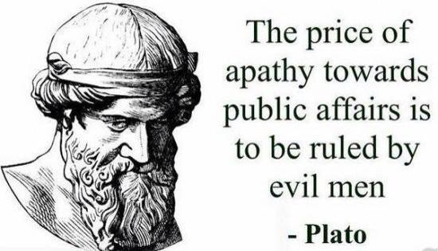

The Universal Hypocrisy of the Illusion of
“Law and Justice for all”
In the UK, we have the Police and the CPS. Now, the Police – every single one of them – swore an Oath of Honour to always uphold the Law.
English
I, ... of ... do solemnly and sincerely declare and affirm that I will well and truly serve the Queen in the office of constable, with fairness, integrity, diligence and impartiality, upholding fundamental human rights and according equal respect to all people; and that I will, to the best of my power, cause the peace to be kept and preserved and prevent all offences against people and property; and that while I continue to hold said office, I will to the best of my skill and knowledge discharge all the duties thereof faithfully according to law.
http://en.wikipedia.org/wiki/Police_oath
The Queen swore an oath on her Coronation in 1953, to uphold the laws and customs of the UK (Common Law)
After the people acclaim the Sovereign at each side, the Archbishop administers an oath to the Sovereign. Since the Glorious Revolution, the Coronation Oath Act of 1688 has required, among other things, that the Sovereign "Promise and Swear to Govern the People of this Kingdome of England and the Dominions thereto belonging according to the Statutes in Parliament Agreed on and the Laws and Customs of the same". The oath has been modified without statutory authority; for example, at the coronation of Elizabeth II, the exchange between the Queen and the Archbishop was as follows:
The Archbishop of Canterbury: "Will you solemnly promise and swear to govern the Peoples of the United Kingdom of Great Britain and Northern Ireland, Canada, Australia, New Zealand, the Union of South Africa, Pakistan and Ceylon, and of your Possessions and other Territories to any of them belonging or pertaining, according to their respective laws and customs?"
The Queen:" I solemnly promise so to do."
http://en.wikipedia.org/wiki/Coronation_of_the_British_monarch
So we are all equal under the LAW, even them. Since before they are policemen, judges, lawyers etc, they are all Human Beings in a Common LAW Jurisdiction.
These are the facts of the matter.
So where does the illusion come in? I hear you ask.
We have Common LAW and we have Statue LAW, both of which cover both Criminal and Civil matters.
Subsequently, it has been my personal experience that the Common Man can only obtain access to Justice in Criminal matters when both the Police and the CPS agree that:
Firstly, a crime has been committed, there is a case to be heard and pursued and, most importantly to them, there is a good chance of a conviction. Only when those two Government paid-and-controlled organisations agree, can you start to get anywhere near obtaining the justice that you are entitled to.
As I'm sure you will agree, the case I have just outlined has certain merits to it, especially when you include this quote by Lord Denning, who was Master of the Rolls at the time:
“To no-one will we Deny or Delay right to Justice.”
Lord Denning, quoting from Magna Carta and is of course also a Roman Maxim.
Of course, what that should say is, “To no-one with money, power and political influence will we deny or delay the right to justice”.
That would be much closer to the truth. For those without any of the above, it’s tough shit.
There is one rule for the rich and powerful and another completely different set of rules for everybody else, which is also the case in Civil Law.
You can initiate Civil cases yourself, so there are no problems there. The problems arise when you send them to the Courts, whether it be Local County Court or the High Court in Strand WC2.
They will use blocking tactics to frustrate and dismay you, in order to get you to drop whatever case it is. As I, along with many others, I have firsthand evidence of these tactics being deliberately employed, especially when the defendant is one of their buddies. (Banks and Corporations)
So I can quite calmly and factually state that the ideas of Justice for all and that we are all equal under the law are just illusions.
Moreover, one can find other ways of receiving Justice and a fair hearing, as you will see below. ☺
Or you can go to this website and ask Keith
http://www.keithordinaryguy.org.uk

An apathetic society, is a
domesticated debt-slave society,
being led like Lambs to the Slaughter.

Cancer – the Big “C”
It is my considered opinion that in my lifetime of 54 years, the rate of cancer per head of population, has grown consistently from 1 in every 4 or 5 people in 1960, through 1 in 4, and 1 in 3 people in 2014. Moreover, by the time this book is published it may even be lower.
So That is an estimated 33% to 50% of the entire UK population who will get cancer in their lifetime. Or that is what we are told. These are the figures bandied about in the media.
However, it has come to my attention that there is one group in this country that, to my knowledge, has not been affected by this incremental rise in death and pain. They have seemingly escaped this onslaught that has overwhelmed the rest of us. And that group is called the British Royal Family.
Do you think that they might have access to things that we do not? Is it also feasible that you could extend that group to include high-level politicians as well, since very few of them seem to be afflicted in the same way as the rest of the population?
The Real Mentally-Deranged
Psychopathy, Sociopathy and Narcissism are serious mental illnesses. Therefore, I thought I would inform you of the nature of the problem we face. You see, all true Psychopaths and Sociopaths, only want one thing – POWER and control over another, or many Human Beings.
They want all the power and control they can possible get, using fear and intimidation as their primary weapons. Therefore, they purposefully and deliberately create a world that is full of fear, death and chaos – ordo ab chao – to satisfy their never-ending lust for power and control
And guess what we already know deep down – where 650 narcissistic psychopaths and sociopaths hang out: Westminster.
Or do you think it is time to stop listening to all the mentally ill people who think they have power and control, over you? And to start listening to ourselves, as only then can we start to heal ourselves of the years of bombardment that we have suffered through their collectivist MIND CONTROL.
So you can finally open yourself up to and harmonise with the Truth, the Light and Real Freedom, for the first time in your entire life. ☺
The Bottom Line
What this all boils down to is this – the suppression of Knowledge. Therefore Knowledge has to be the KEY to our survival, both individually and as a species. Moreover, it is what they don't want you to know. There are no external saviours on the way to help us, however much you may pray for one. Although there is a reason for this and the reason is quite simply this:
You are the ONE
You need to be your own Saviour.
Yes, you – not anybody else, just you.
Why is that the case? Because when everything comes down to the bottom line, the only person in this Universe that can save you is you. As only you can shatter the chains of enslavement that have been placed in your mind, the same as they were placed in mine.
All I can do is show you that it is possible, as that is all anyone can do. As neither me nor anybody else can do it for you.
That is why you are NEO, you are the one you have been waiting for all these years. So wake up, break your programming, break the mental chains and start to realise and feel just how powerful you really are. As you are a Sentient Being of and from the Universe, just the same as all other Human Beings. You have inherent and inalienable rights given to you by the Universe not by MAN. Therefore, no-one can trespass on them or take them away
without your consent.
Therefore I am and you are
THE LIGHT
THE MONARCH (but only of oneself)
THE HIGHEST SPIRITUAL OFFICE (but only of oneself)
THE COMMANDER in CHIEF of all of the ARMED FORCES
at your disposal (which is yourself)
I do not recognise Government
and/or any Officials and/or Agents so attached.
I only recognise Human Beings in a Common LAW Jurisdiction
as a peaceful inhabitant of these islands,
commonly known as the British Isles.

The REAL TRUTH
As the saying goes and as you have now discovered, the Truth will set you Free. However, you first have to know what the truth actually is before you can be truly free. The ultimate undeniable Truth is
“That which is”.
Every thought and emotion you have had, every word you have spoken, every action you have initiated. All past events are part of the Truth, as they happened and cannot be changed.
All the good or bad things you have ever done are preserved in time forever, along with all the pain you have felt. And thus conversely, all the pain you have caused. You can't go back and undo or un-feel those things – none of us can.
It all becomes part of the flow of time – the individual included in the whole of ‘that which is’, with the turning of the planet and the tides of the sea.
The Truth is 'that which is', that which we can't change.
All we can change is ourselves. Consequently by doing that, we each change the reality for everybody else around us.
That is why I said earlier that the Past has no Possibilities. Possibilities can only exist in the present and in the future.
You have to be the change you seek.
This quote is on my laptop’s desktop to remind me every day:
WE ARE ALL VISITORS HERE TO THIS TIME, THIS PLACE.
WE ARE JUST PASSING THROUGH.
OUR PURPOSE HERE IS:
TO OBSERVE
TO LEARN
TO GROW
AND THEN TO RETURN HOME.
Australian Aboriginal proverb
As the greatly-missed Bill Hicks used to tell us:
IT’S JUST A RIDE ☺
So do your best with the time you have left in this incarnation. Be the best Human Being you can possible be. Otherwise, you will have to come back again and learn the things you neglected to learn this time around.
Yes, it’s tough, but it’s worth it. To quote the song: “when the going gets tough, the tough get going”.
So are you going to show yourself just how tough
you really are and join those already
on the path to Mental and Spiritual Freedom?
Many hands make light work and I look forward to a brighter, happier and far safer future for all of us.
Then we can start to call them, the System Controllers, and we can tell them this: ☺
“I know you're out there. I can feel you now. I know that you're afraid ... you're afraid of us. You're afraid of change. I don't know the future. I didn't come here to tell you how this is going to end. I came here to tell you how it's going to begin. I'm going to hang up this phone and then I'm going to show these people what you don't want them to see. I'm going to show them a world without you.
A world where anything is possible.”
Neo, The Matrix, 1999:
We are each our own ONE.
Only one person has the real power to change you
and that one person is YOU. ☺

The Best Laid Plans of Mice and Men
For millennia, they planned it.
As their view of the world
Kept expanding and expanding,
They never faltered, not once.

As the centuries flashed by,
They slowly tightened their grip.
First Europe and then
The New World of the Americas.

The world full of possibilities
To usher in their plans.
First Catholicism and then
Claiming the planet, as in 1305.

Empires rise and fall,
But, Rome lives on and on,
As it does to this day,
Hoarding the Wealth of Nations.

While they bring in the big guns,
The Freemasons wet dream
A Democratic Republic
All fresh and shiny and new.

Followed swiftly by the arch villains
Boo, Hiss, Boo
As they stalk in the shadows,
Fearing the light of publicity.

They do all their deals in private
Far from the madding crowd,
cocooned in 5 star accommodation
All at your expense.

On Jeckel Island, they create
Their masterpiece, to control the world:
The Federal Reserve. Made possible
By the Fed Act 1913.

From that day to this, humanity’s fate was
Signed, sealed and soon to be
Delivered. For them to gorge themselves
on the blood of the sole dyers (soldiers)

As bullets cost money, as they always have
And money means profit
And the biggest profit is in
War time.

The 20th century being the
Bloodiest and most
Expensive one so far, and we are
All still paying for it.

War against terror anybody?
They will keep that one going
As long as possible,
Whilst hiding the truth

That they instigated it all,
They were behind it
They are the terrorists
Who are the terrorists?

They are behind you
In their protected offices
Edifices of ROME, with their obelisks
Seemingly all over the planet.
And now, just as they were
So close to their goal,
The illusion they created
Is starting to melt away.

There are holes appearing
Everywhere, it is becoming obvious
Even to those they call
“the farm animals”.

Game’s up, boys,
You have been discovered,
Although not on the
Discovery Channel.

People Power, the irrepressible
Human Spirit rises again,
Like the proverbial phoenix,
To snatch victory from defeat.
Because we will not
Be slaves to the Bankers
Or anybody else, for we are
FREE NOW AND FOREVER
1381
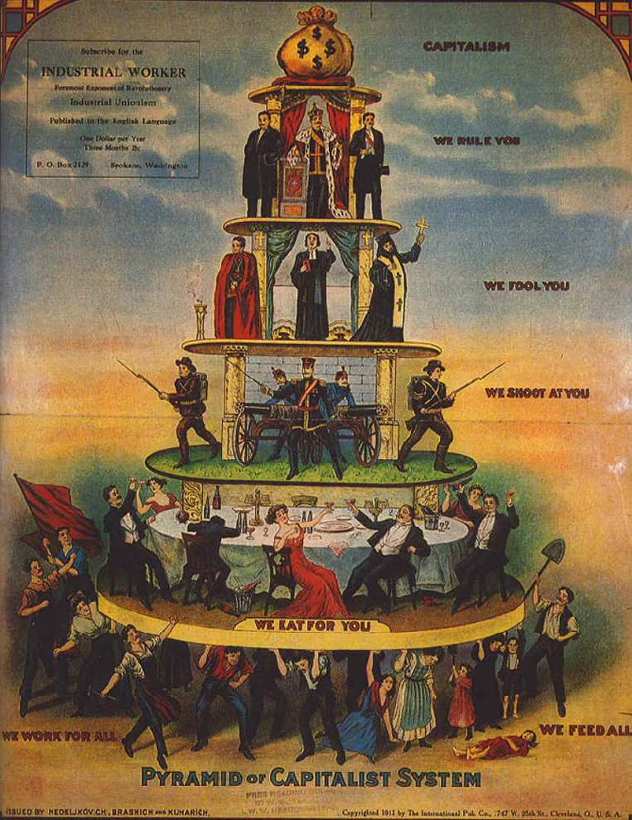

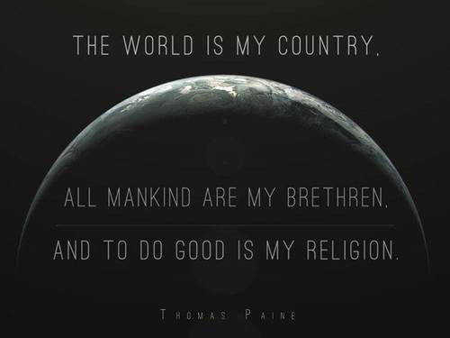

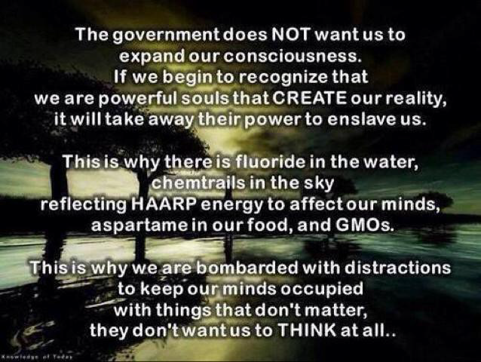

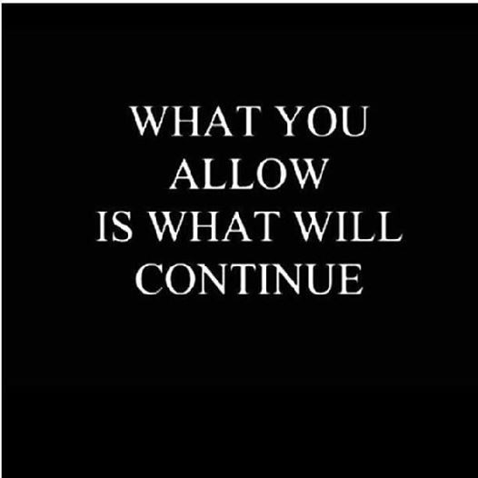

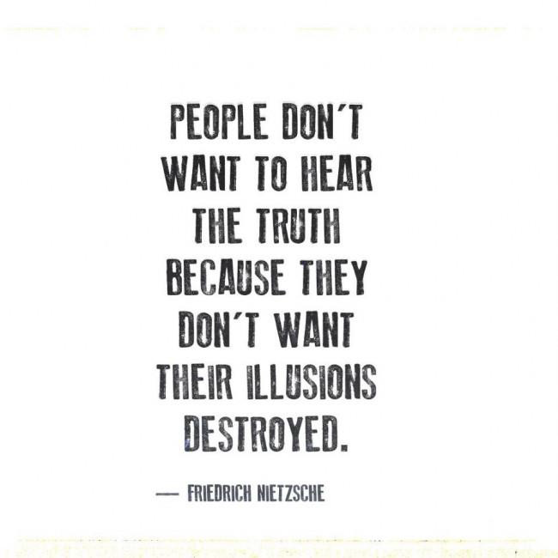

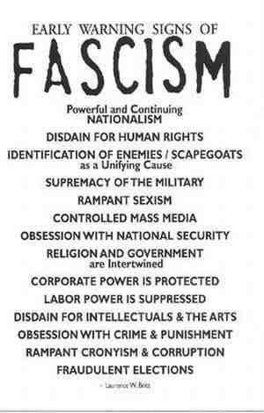
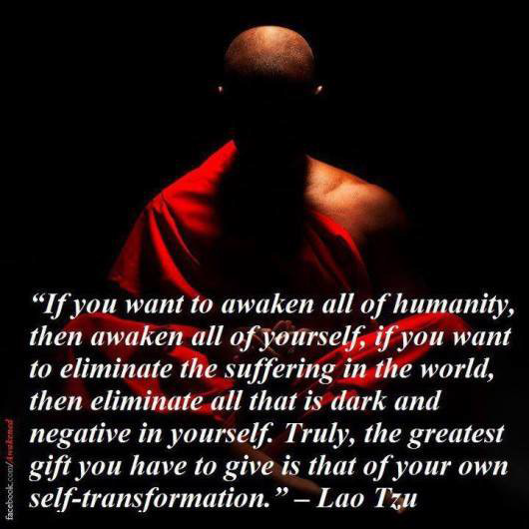

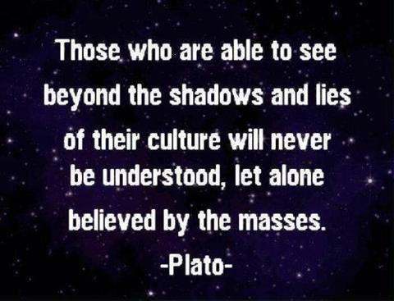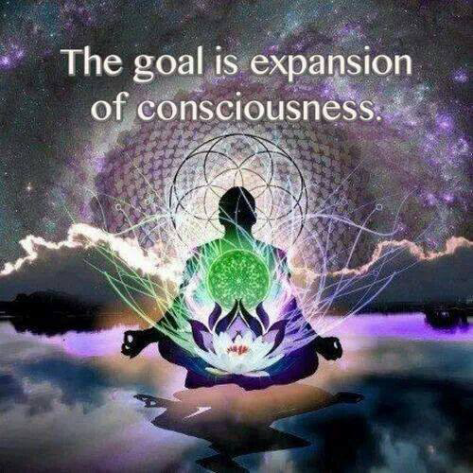
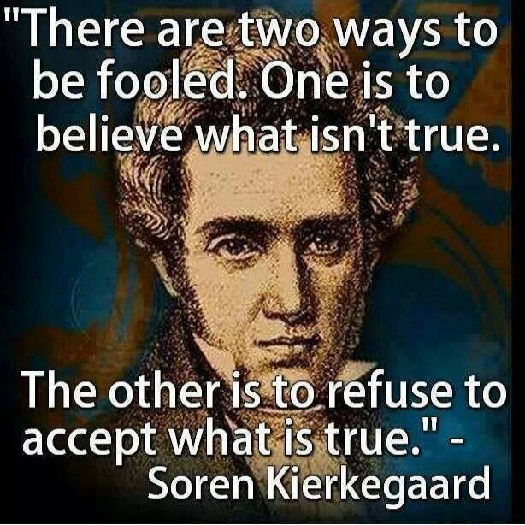
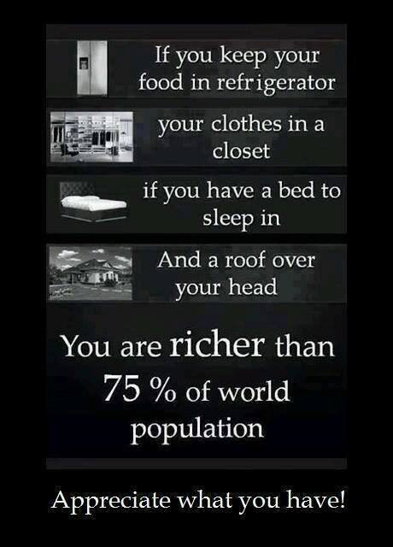

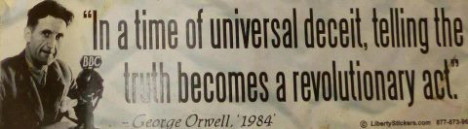

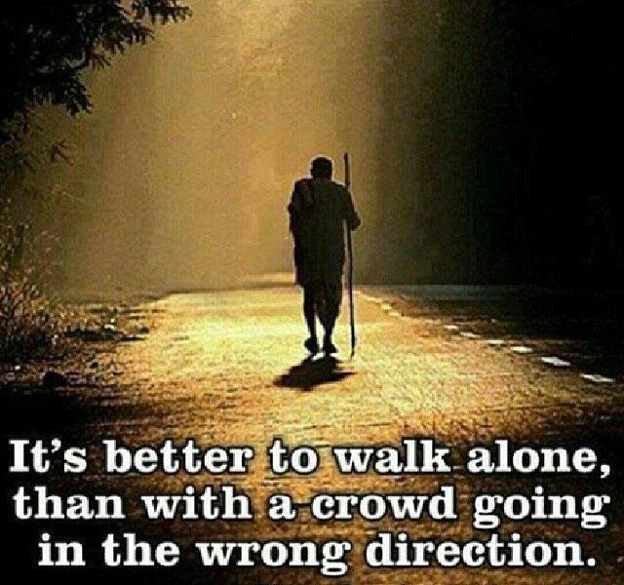

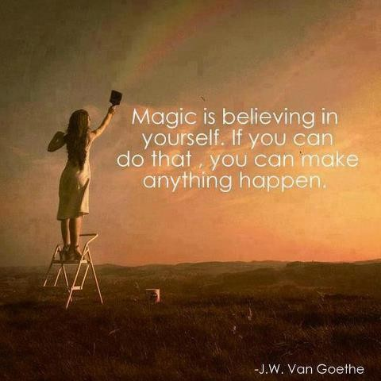

Other web sites to research
http://www.getoutofdebtfree.org
https://www.youtube.com/watch?v=zSoA8qQW2uQ
http://www.yourstrawman.com
The Four Horsemen-https://www.youtube.com/watch?v=5fbvquHSPJU
The Freedom Movie-https://www.youtube.com/watchv=6XvcIpB5pjM&index=1&list=PL7D17BCB07E0EF28C
Meet your Strawman-https://www.youtube.com/watch?v=ME7K6P7hlko
Consent of the Governed-https://www.youtube.com/watch?v=6RLHsH7XAkc
What happens to you after you die.
Journey of Souls- Dr Michael Newton (Book)
For real news that the mainstream media would not dare print or show you go to- http://www.ukcolumn.org
Street Wise Spirituality Mark Passio https://www.youtube.com/watch?v=oOYTHg8cadY
The Fluoride Deception
https://www.youtube.com/watch?v=XuTD-FGwLr0
100 + Documentaries on various subjects
http://higherperspective.com/2013/11/166-doc-expand-your-mind.html#BqFZY5yo6iLeMQzr.99
My apologies if some of these web sites and u-tube presentations no longer exist-as it has taken me another three years to get to this stage.

The End
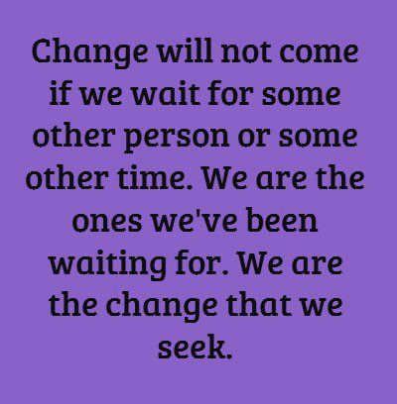
BACK PAGE- WITH THE WORDS.
THIS IS WHAT MIND CONTROL LOOKS LIKE TO SOMEONE WITH A FREE MIND

